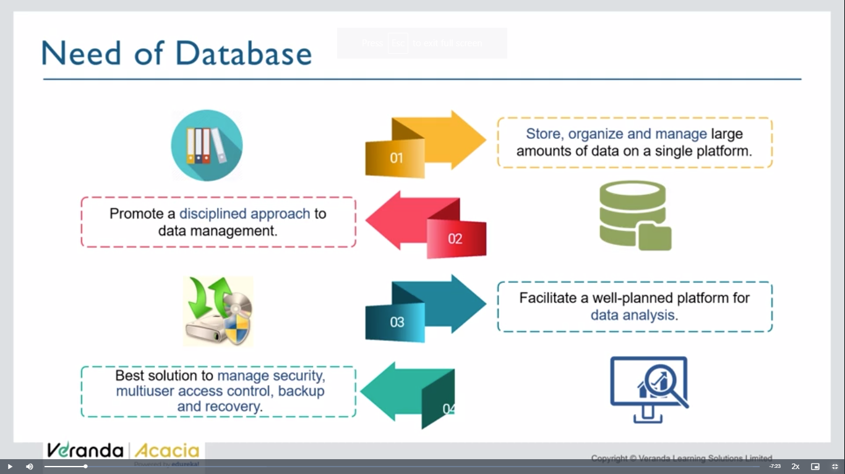

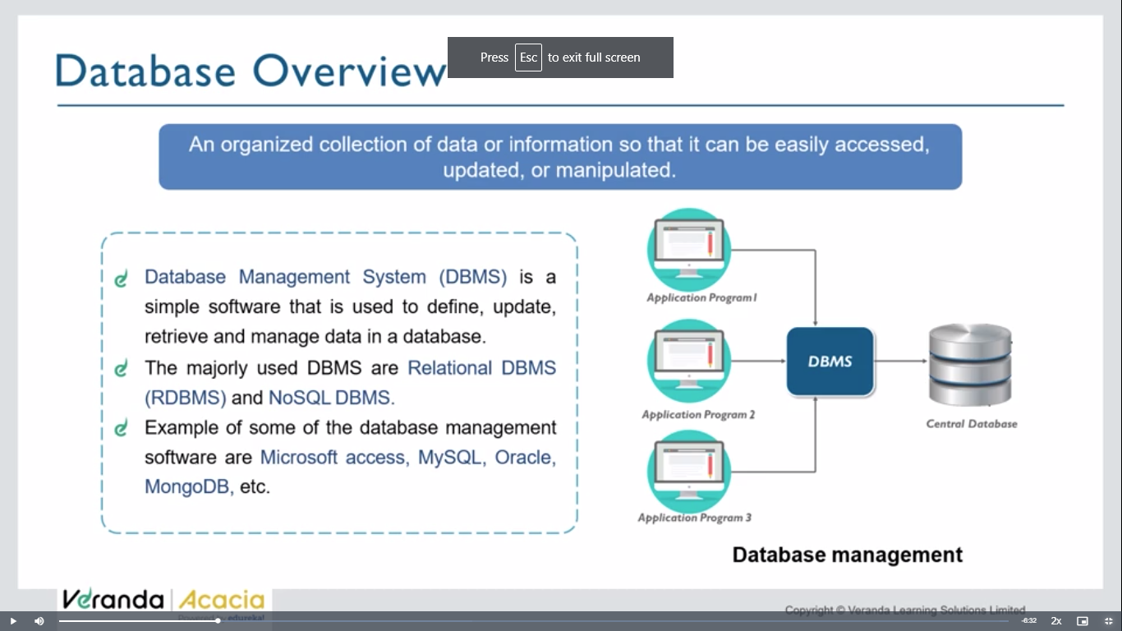

We do 4 operations on db- CRUD

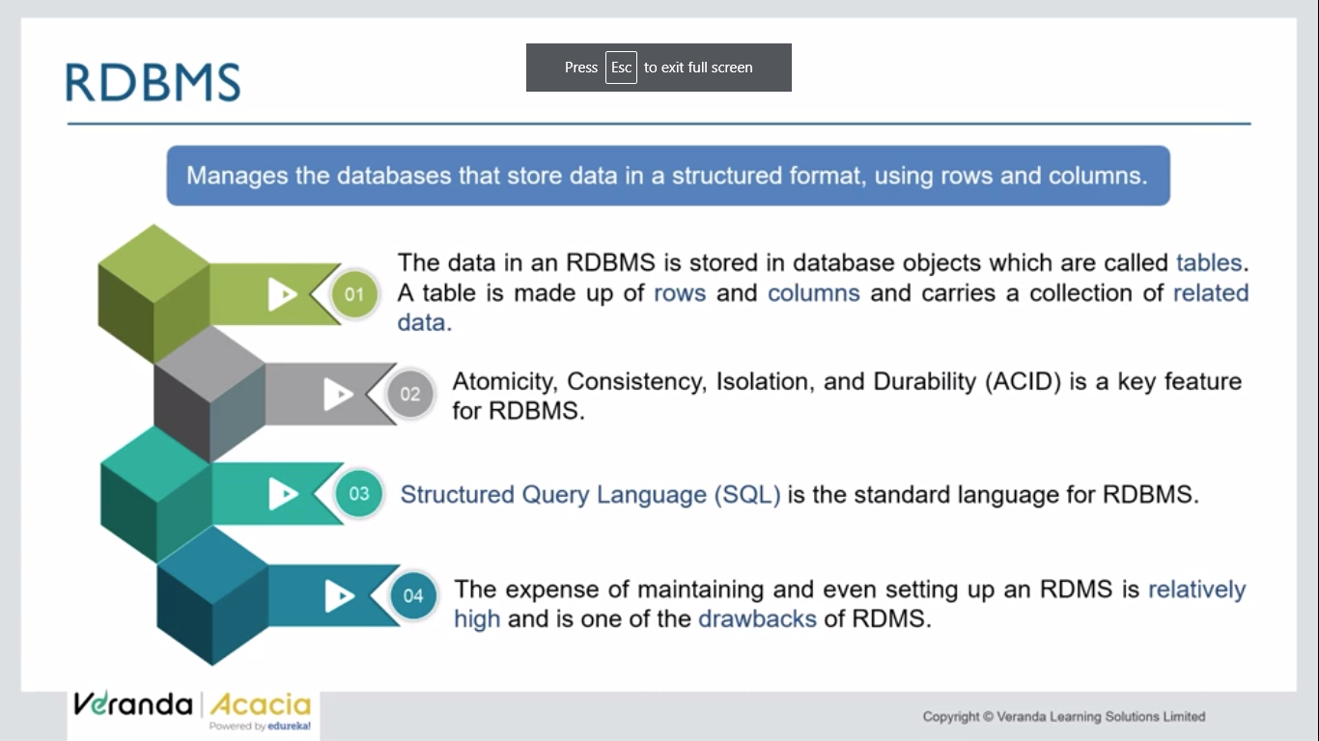

ACID is an acronym that refers to the set of 4 key properties that define a transaction: **Atomicity, Consistency, Isolation,** and **Durability.** If a database operation has these ACID properties, it can be called an ACID transaction, and data storage systems that apply these operations are called transactional systems. ACID transactions guarantee that each read, write, or modification of a table has the following properties:

* **Atomicity** - each statement in a transaction (to read, write, update or delete data) is treated as a single unit. Either the entire statement is executed, or none of it is executed. This property prevents data loss and corruption from occurring if, for example, if your streaming data source fails mid-stream.

Atomicity – one task must be fully completed or fully aborted

* **Consistency** - ensures that transactions only make changes to tables in predefined, predictable ways. Transactional consistency ensures that corruption or errors in your data do not create unintended consequences for the integrity of your table.
* **Isolation** - when multiple users are reading and writing from the same table all at once, isolation of their transactions ensures that the concurrent transactions don't interfere with or affect one another. Each request can occur as though they were occurring one by one, even though they're actually occurring simultaneously.
* **Durability** - ensures that changes to your data made by successfully executed transactions will be saved, even in the event of system failure.

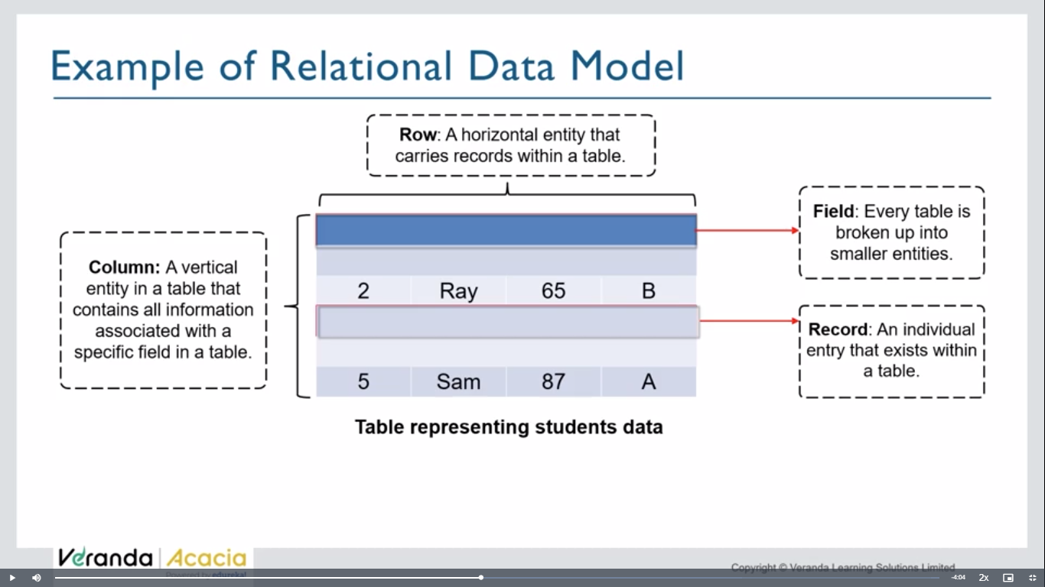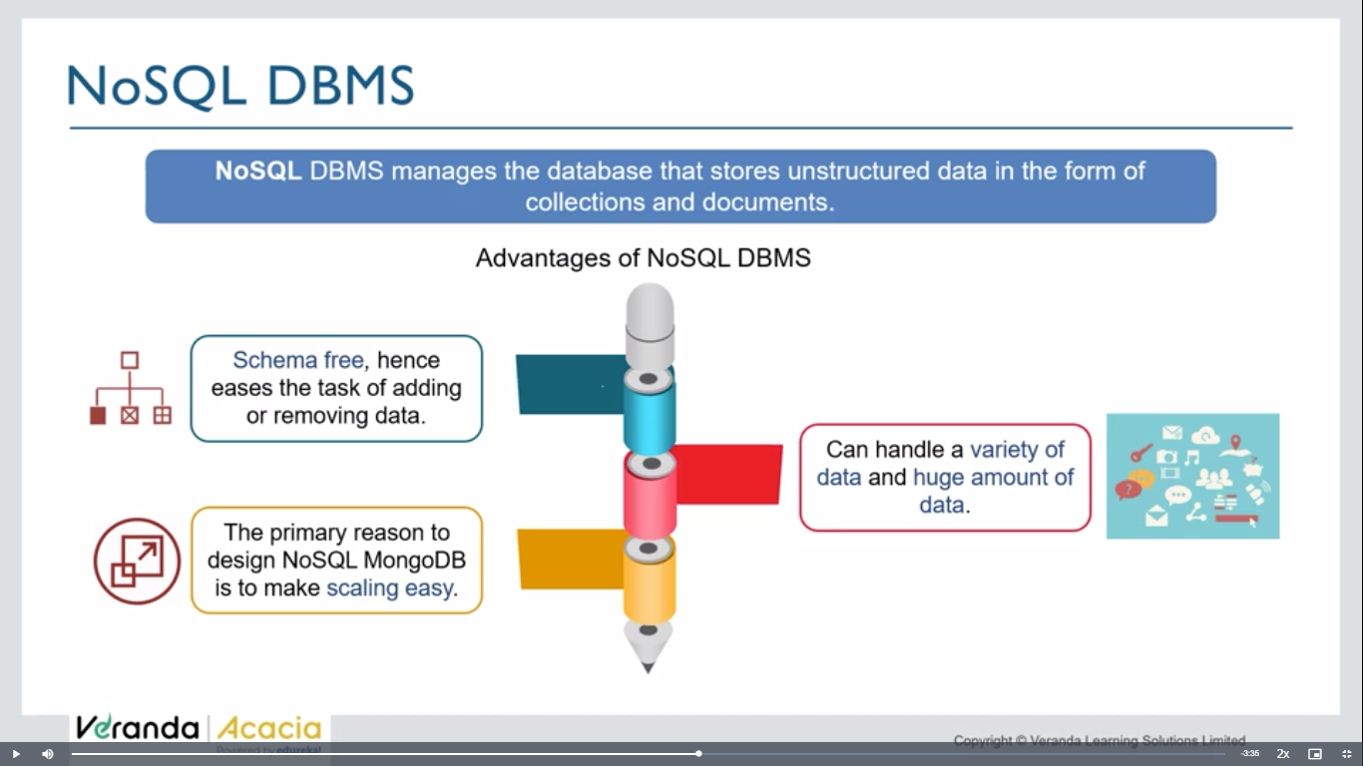

They don’t use db, can use docuemnts / any form

Rows in sql => collections in mongodb

Columns in sql => document s in mongodb.(key-value pairs)

{

Name: ‘zee’, //key-value pairs - documents

Age:23

},

{

Name:

}

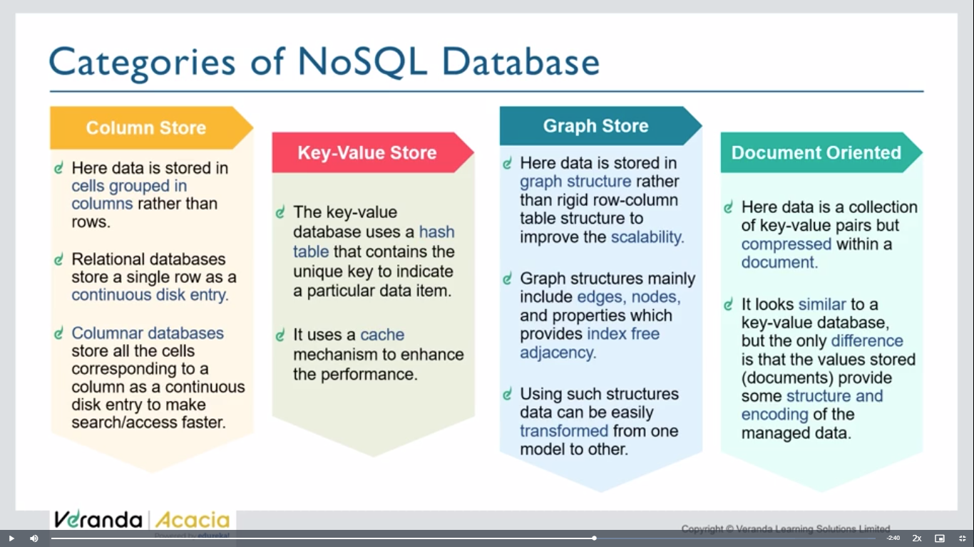

Data can be in above forms

Mongodb – document orientated db

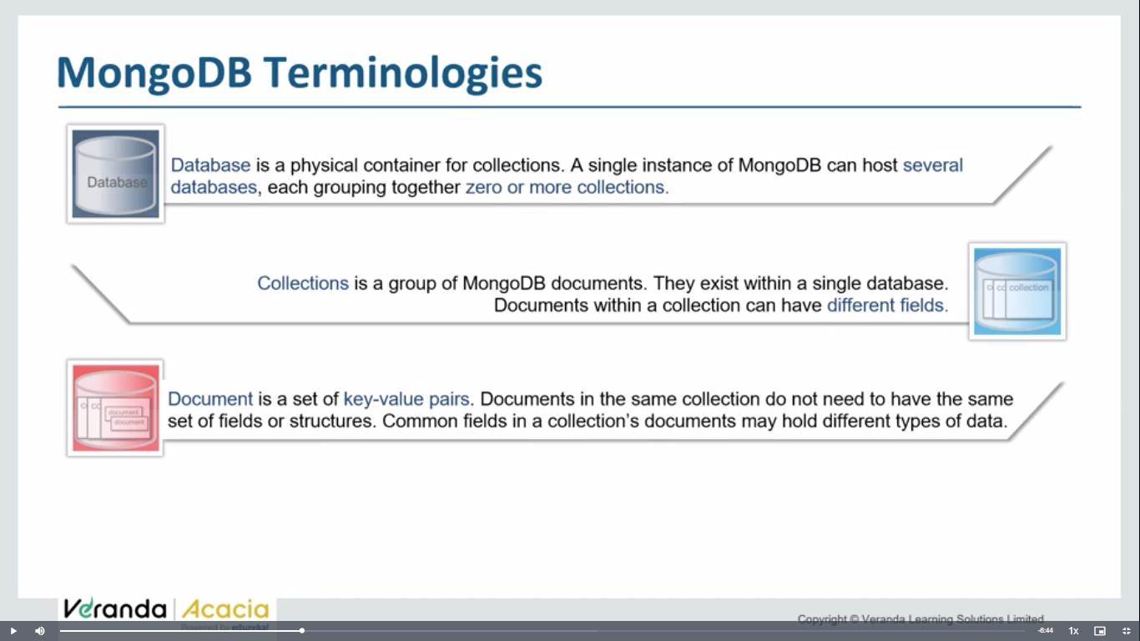

**Day 58: mongodb installation**

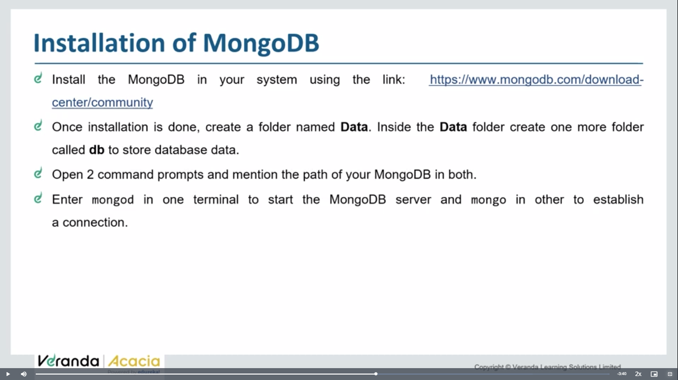

You can begin to download MongoDb from [here](https://www.mongodb.com/try/download/community).

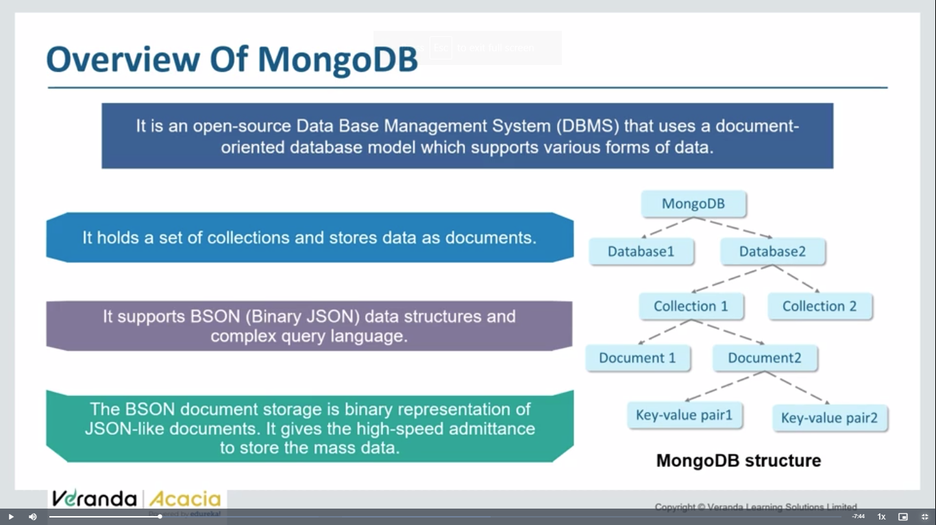

**Mongod- mongodb server**

**Mongosh- mongosh**

<https://www.mongodb.com/try/download/community>

download mongodb link

create datafolder in c drive and inside data create db folder

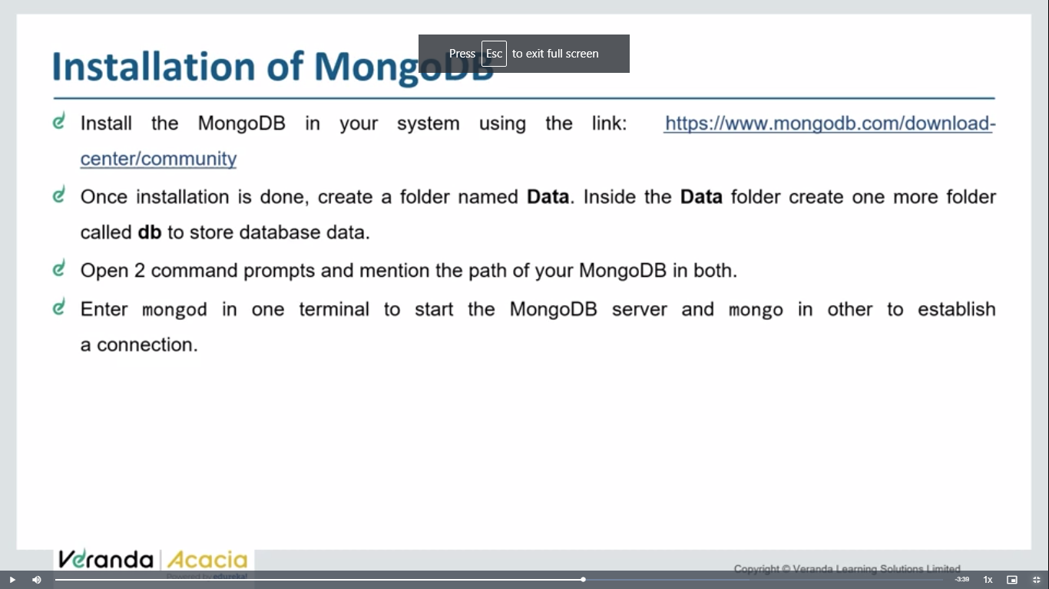

{

Objectid: ‘78739800494’,

Name:’zee’,

Age: ‘25’

},

{

Object id: ‘256636677655’,

Name:’uhuhf’

Age:’67’

}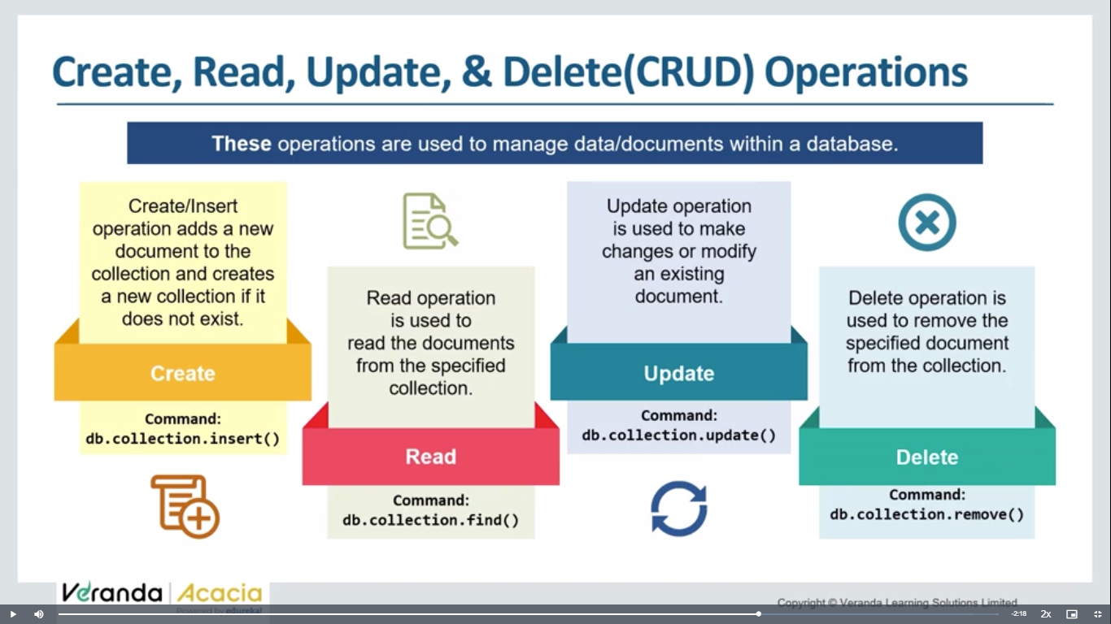 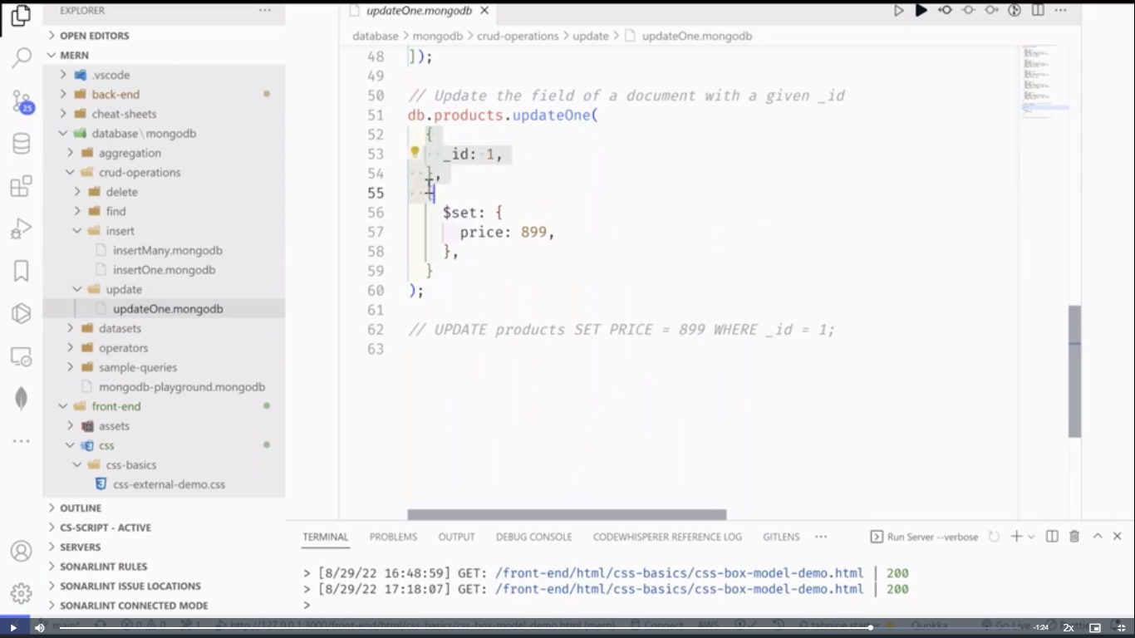 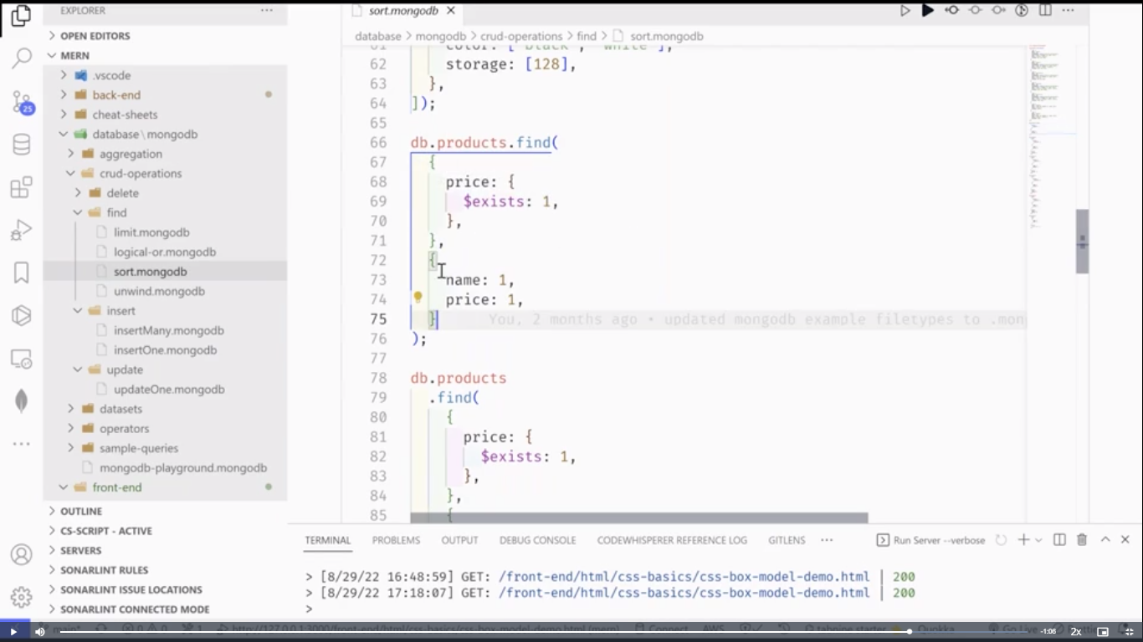 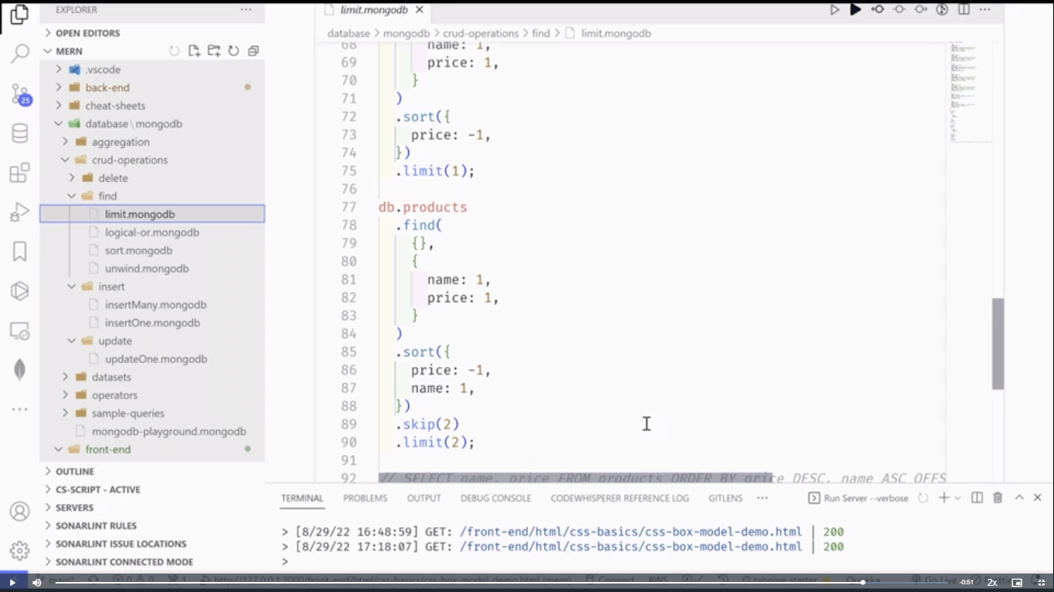

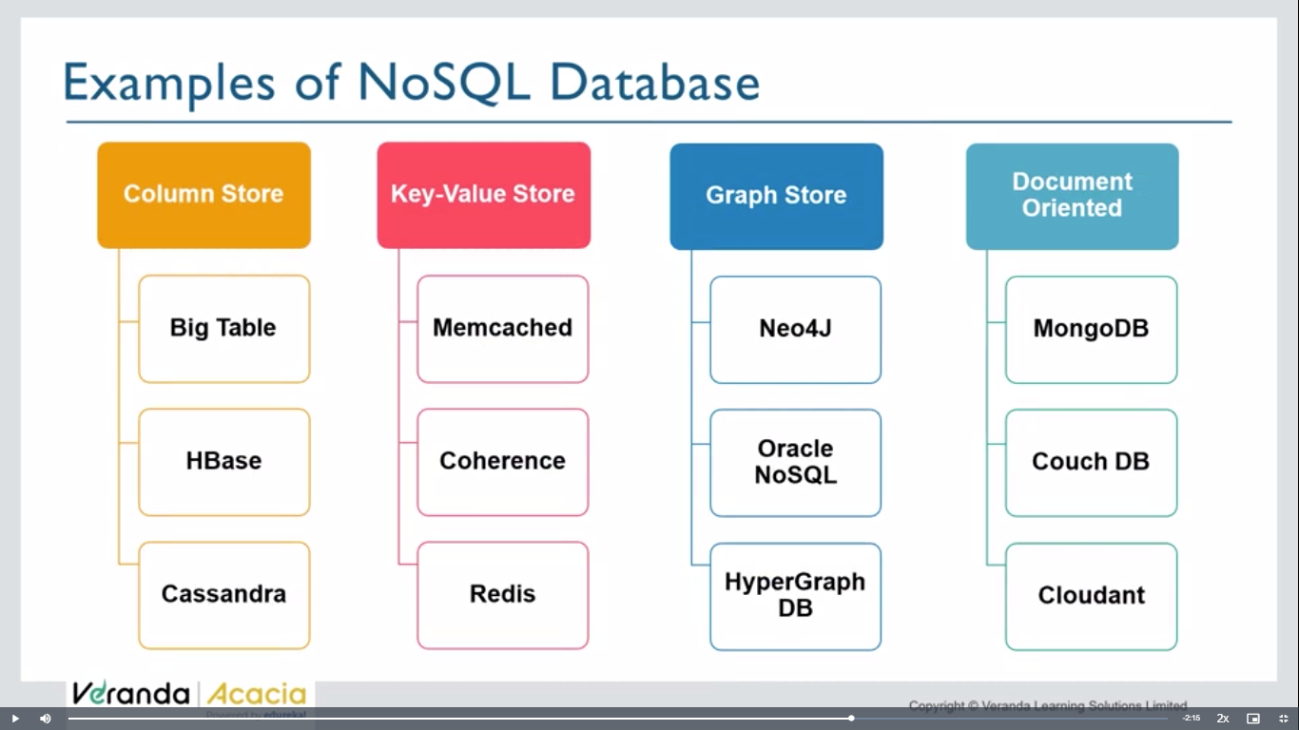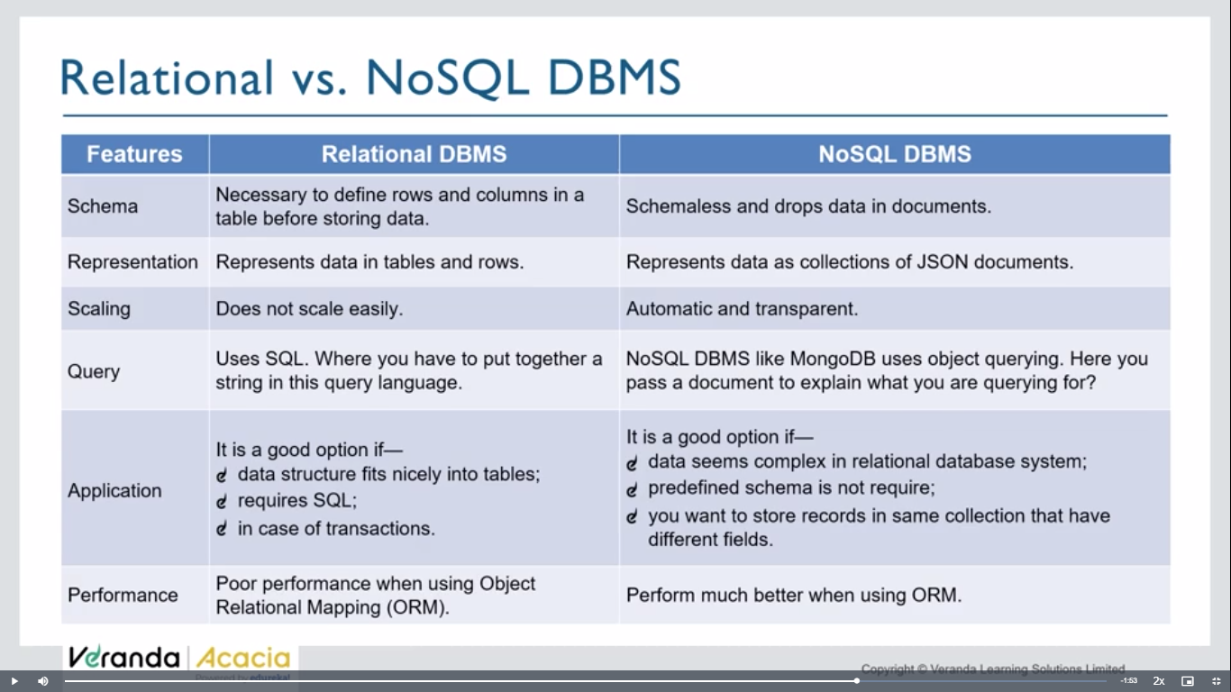

Sql – use if u need ur data in structured manner, and to work with trassacntions

Nosql= if ur data structure is complex, can be scale in future, no need of particular schema

**One way:**

**What is meant by a Document Oriented Database?**

Simply, a document oriented database means which stores its data in the form of documents.

* MongoDb stores data as documents, so it is known as a document oriented database.
* Data is stored in the form of BSON. BSON is almost similar to JSON with the only difference that types of variables are declared in it.
* If you are coming from the DBMS background, then following changes are there-

1. Database is referred to as a database.
2. Table is referred to as a collection.
3. Row is referred to as documents
4. **Binary vs. text**: BSON is a binary-encoded format, whereas JSON is a text-based format. This means that BSON is compact for transmitting over a network, while JSON is human-readable and easier to work with in various contexts.

**Bson -** Supports additional data types such as binary data and date types**{….}**

**Json -**

|  |
| --- |
| Supports strings, numbers, null, arrays, and objects |
|  |

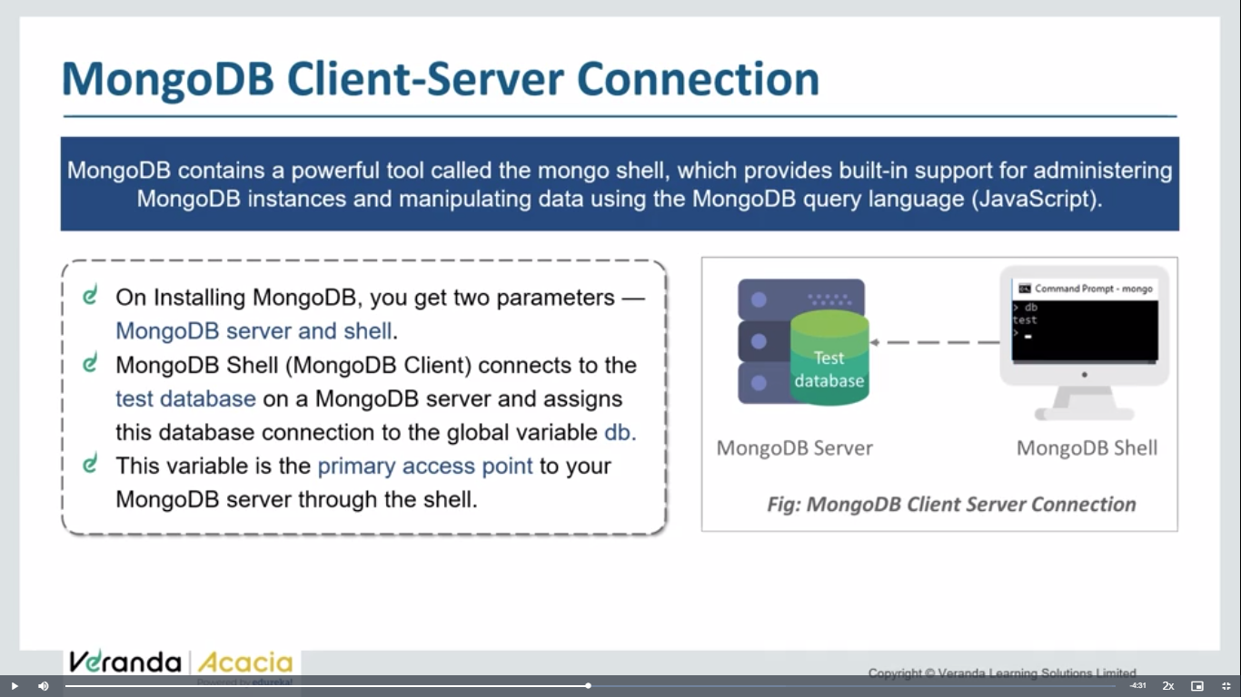

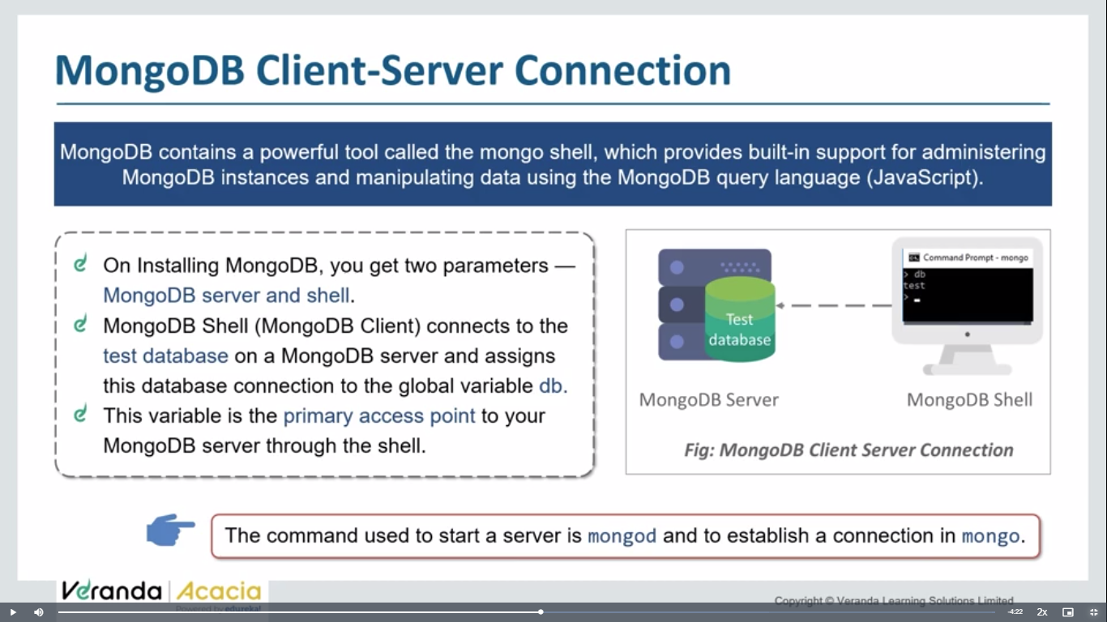

**mongodb crud operations:**

**u can execute below codes in cmd >mongosh or in mongodb compass shell**

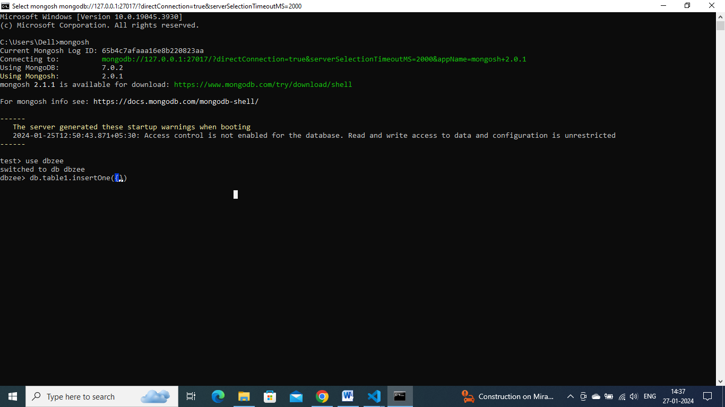

use harryKart

Copy

db.items.insertOne({name: "Samsung 30s", price: 22000, rating: 4.5, qty: 233, sold: 98})

Copy

db.items.insertMany([{name: "Samsung 30s", price: 22000, rating: 4.5, qty: 233, sold: 98}, {name: "Moto 30s", price: 29000, rating: 3.5, qty: 133, sold: 598}, {name: "Realme 80s", price: 129000, rating: 2.5, qty: 633, sold: 98, isBig: true}])

Copy

**db.items.find()**

Primary key here Is object id

**Searching and Querying data:**

// Searching for data in mongo db

use harryKart

// This query will return all the objects with rating equal to 3.5

db.items.find({rating: 3.5})

Copy

This function will return all those items that match the condition. However, we can also use some complex functions like greater than or less than to meet our query as follows-

db.items.find({rating: {$gt: 3.5}})

Copy

We can also use ***and***operator to meet our query. The example is as follows-

db.items.find({rating: {$gt: 3.5}, price:{$gt: 4000}})

Copy

This code will give the list of all those items having ratings greater than 3.5 and having prices more than 4000.

If we write as-

db.items.find({rating: {$lt: 3.5}, price:{$gt: 114000}})

Copy

We will get the output as the list of those items whose ratings are less than 3.5 and price more than 114000.

Till now you must have noticed that in the case of ***And*** operator, we have not used any symbol. But it is not the same in the case of ***Or***. While using *OR* operator, we will use a dollar ‘$’ symbol as follows-

db.items.find({

$or:[{rating: {$lt: 3.5}}, {price:{$gt: 114000}}]

})

It will give the list of all those items having rating less than 3.5 or price more than 114000 as follows-

show dbs

use harryKart

show collections

db.items.find({price: 22000})

// Deleting items from the Mongo Database

db.items.deleteOne({price: 22000})

// deleteOne will delete the matching document entry and will delete the first entry in case of multi document match

db.items.deleteMany({price: 129000})

**updating:**

db.items.updateOne({name: "Moto 30s"}, {$set: {price: 2}})

Copy

db.items.updateMany({name: "Moto 30s"}, {$set: {price: 3, rating: 1}})

Copy

The ***updateMany()*** function is used to update multiple items. Hence after writing the above code, we get the output as follows-

So the things that we were doing earlier with terminals, and command on MongoD, now we can do it by MongoDb Compass GUI.

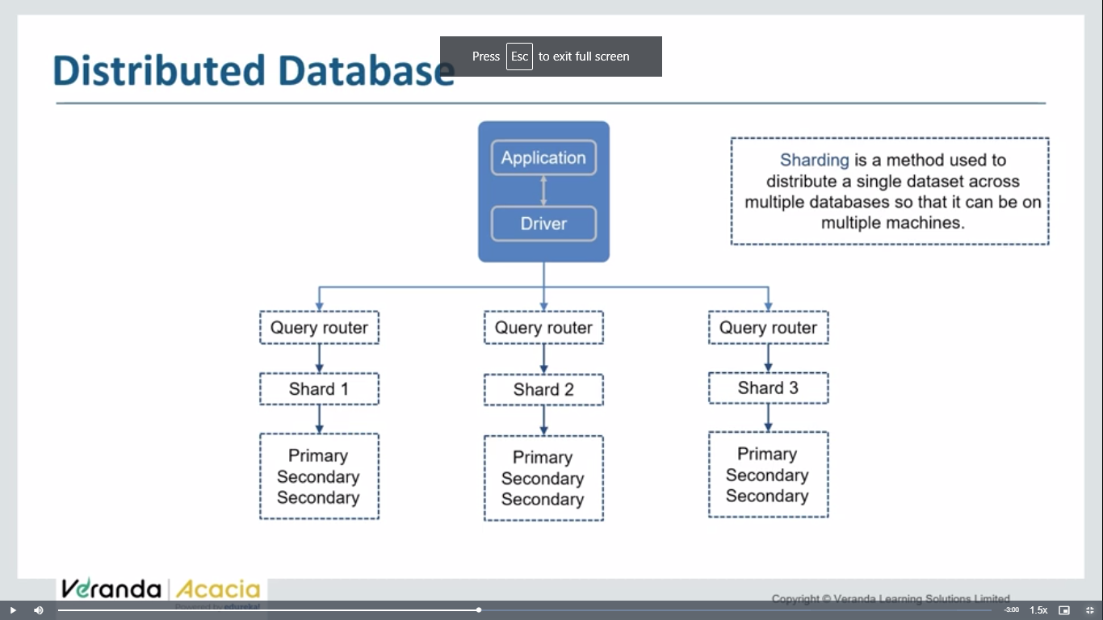



One point to note here is there is no need to write rating, price, or any other schemas while working with MongoDb compass. It provides you all types of flexibility. Also you can take help of filters to find your schemas as shown here-

Let us now see how to connect this MongoDb compass to Node.Js. We can do this with the help of ***Mongoose***. It is an object data modeling (ODM) library that provides a rigorous modeling environment for your data, enforcing structure as needed while still maintaining the flexibility that makes MongoDB powerful.

We will make a new folder as ***Mongoosetut***. We will open the terminal window and install npm. After installing the *package.json*file we will write ***npm install mongoose*** to install the mongoose.

You will get the output as follows-

**Mongodb tutorial:**

**Mongodb**  is a no sql db(not structured)

Data stored in a collection

Collection don’t have row and columns

Data is stored in form of object.(bson format)

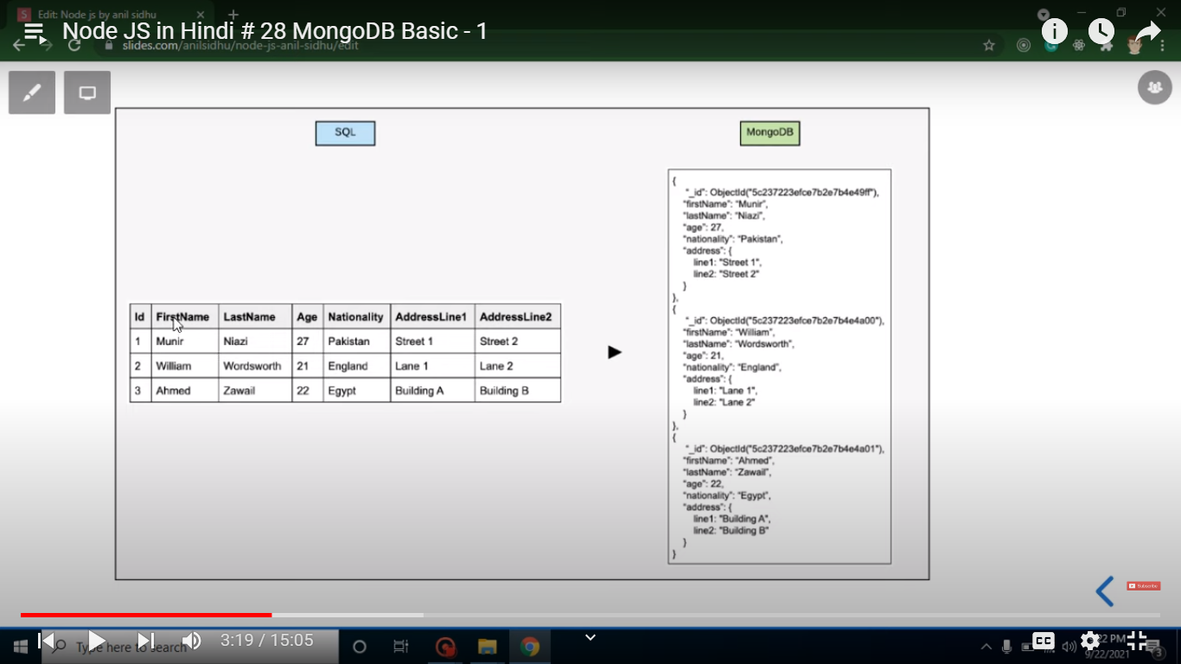

Set bin folder env variable path

Mongod- to start server

Mongosh – to start shell

**Commands:**

**>show dbs**

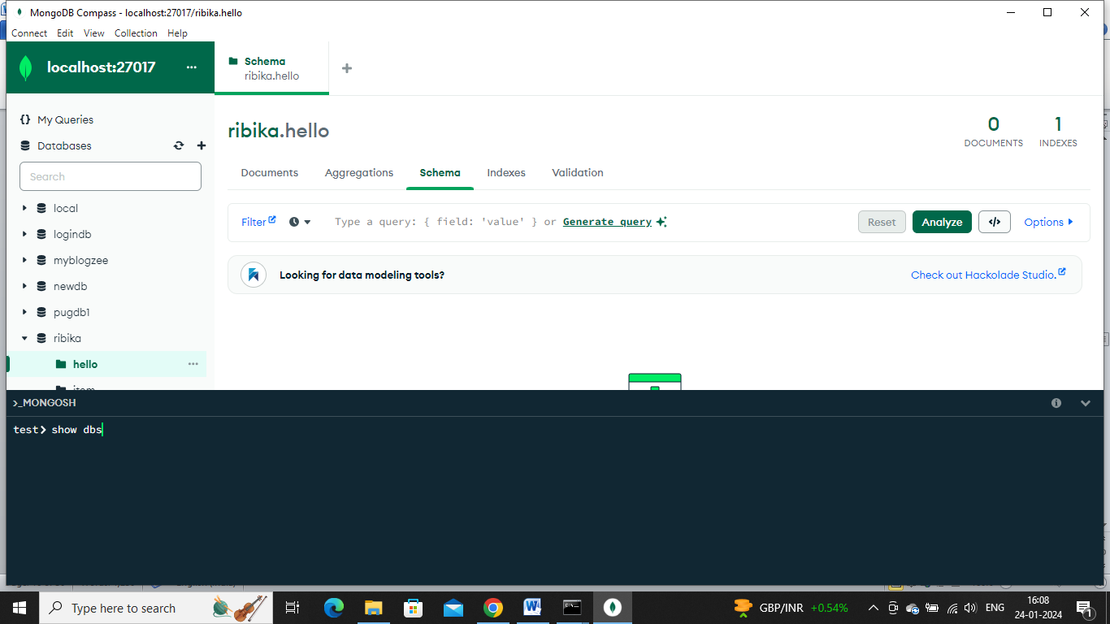

**The above is a mongoshell in mongodb compass**

**Create db:**

**>use dbname**

**Until atleast one collection in db, it will not be visible.**

**>show dbs;**

**>db.createCollection(‘table1’);**

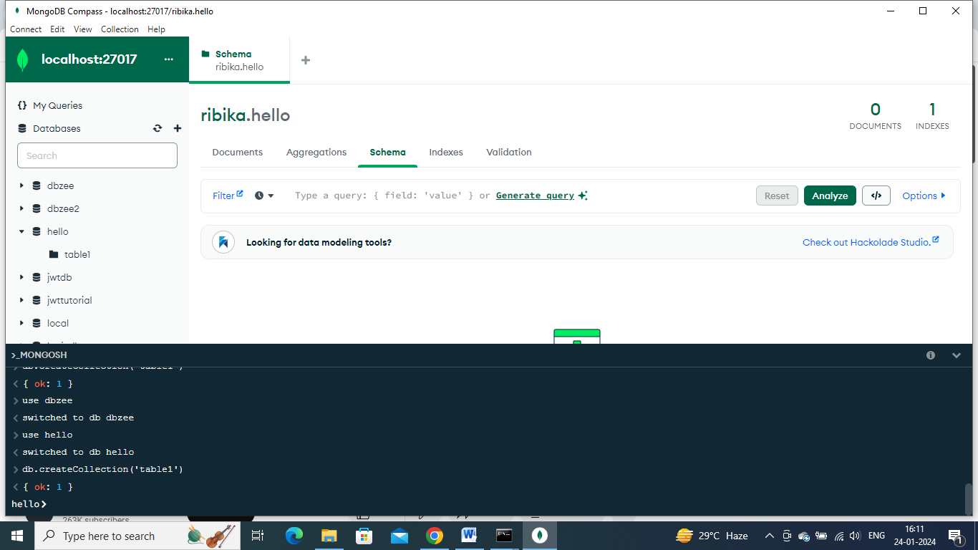

**>show dbs;**

**Show collections;**

**Db.collectionname.drop();**

**Db.table1.drop();**

**To check on which db we are working on now**

**>db**

**To delete a database:**

db.dropDatabase();

**CRUD operations:**

>use ecom

switched to db ecom

ecom>db.products.insertone({name:’jd’,brand:’jhhfjf’,price:788})

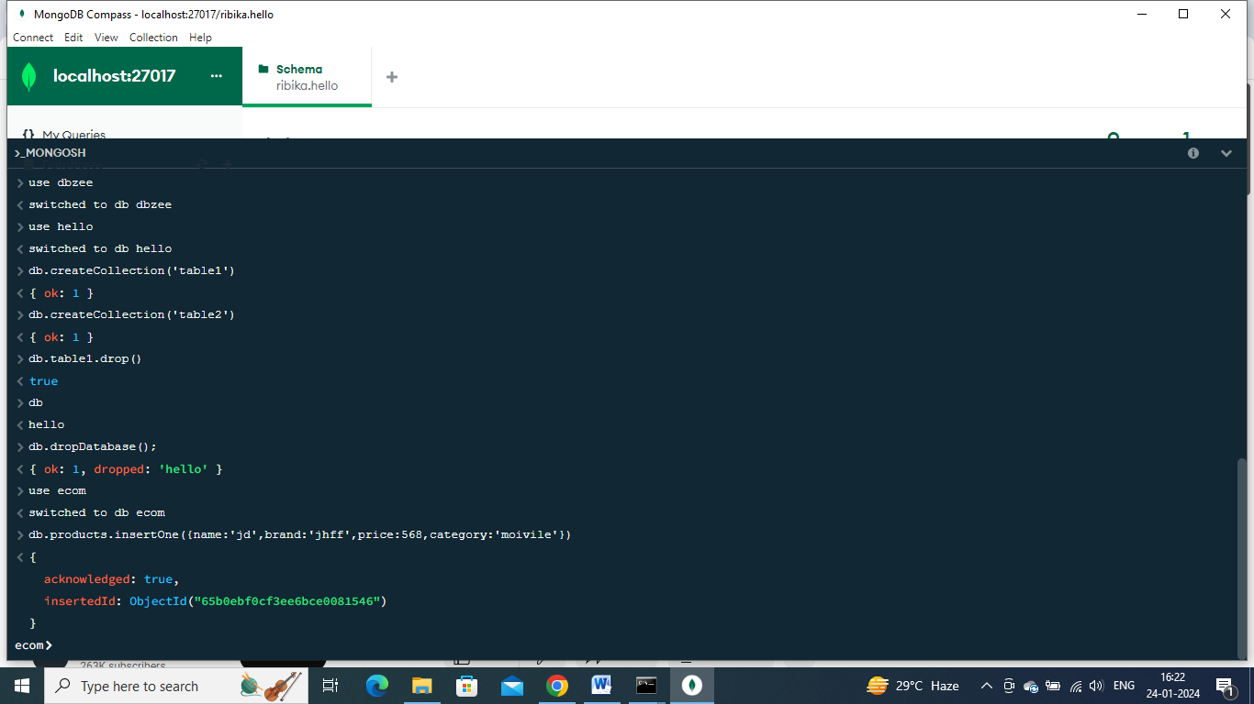

**Other way:**

Add data>insert document

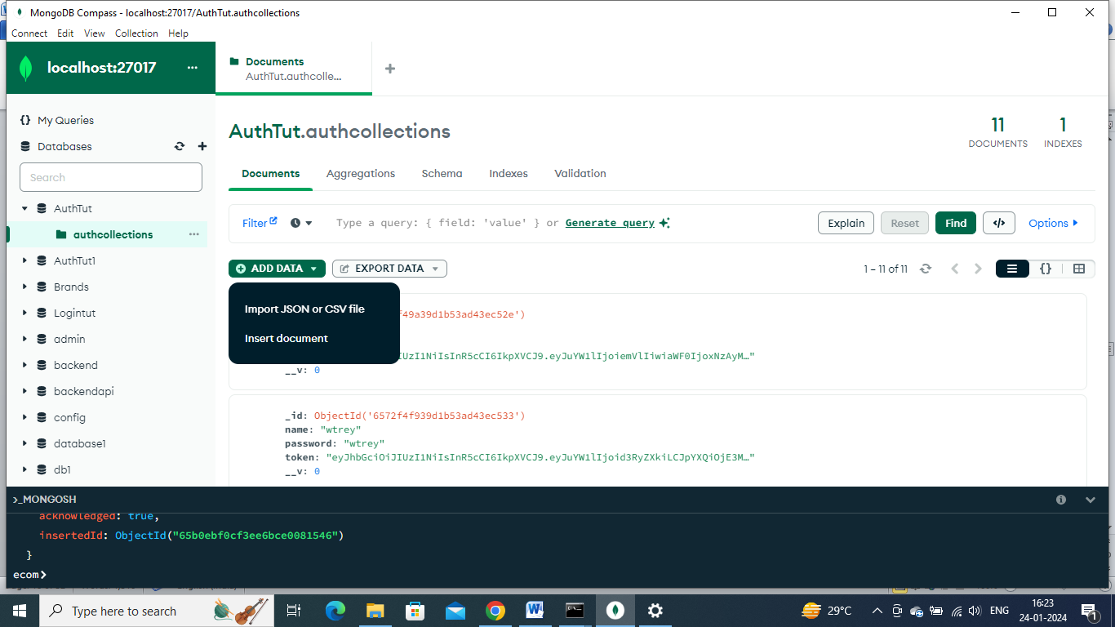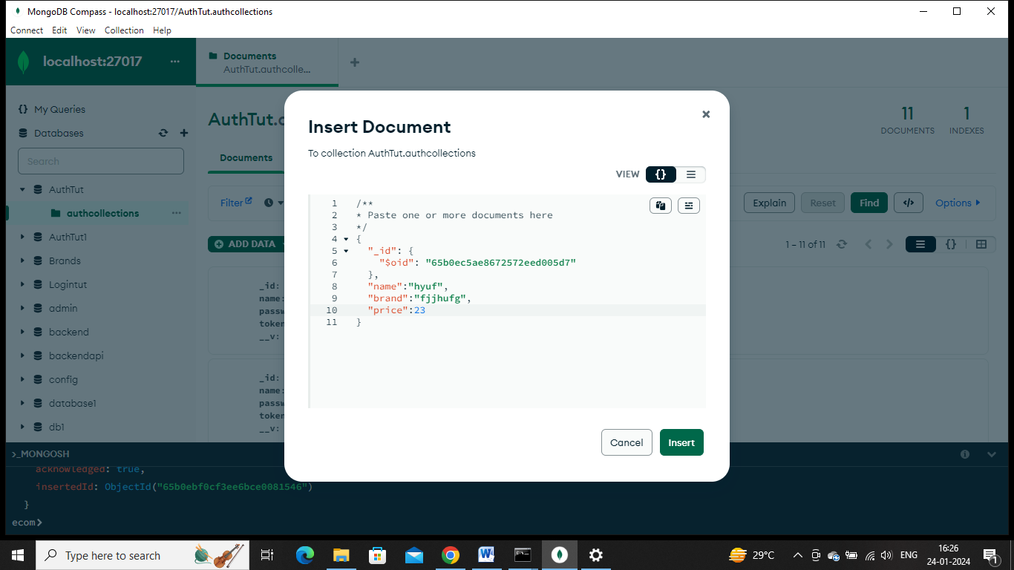

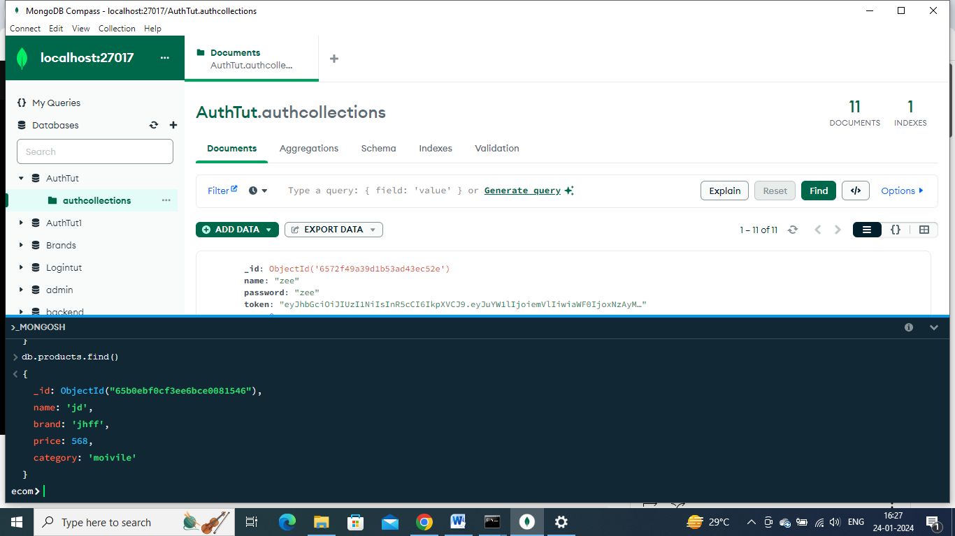

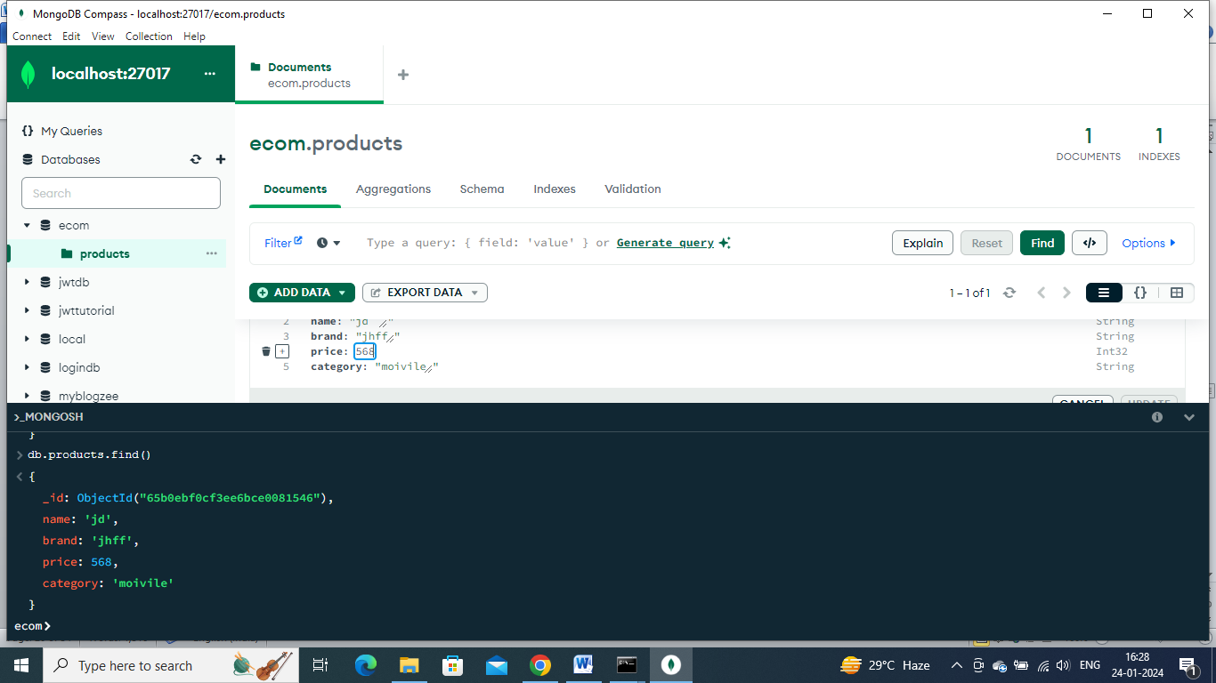

Can edit easily like this and refresh in gui

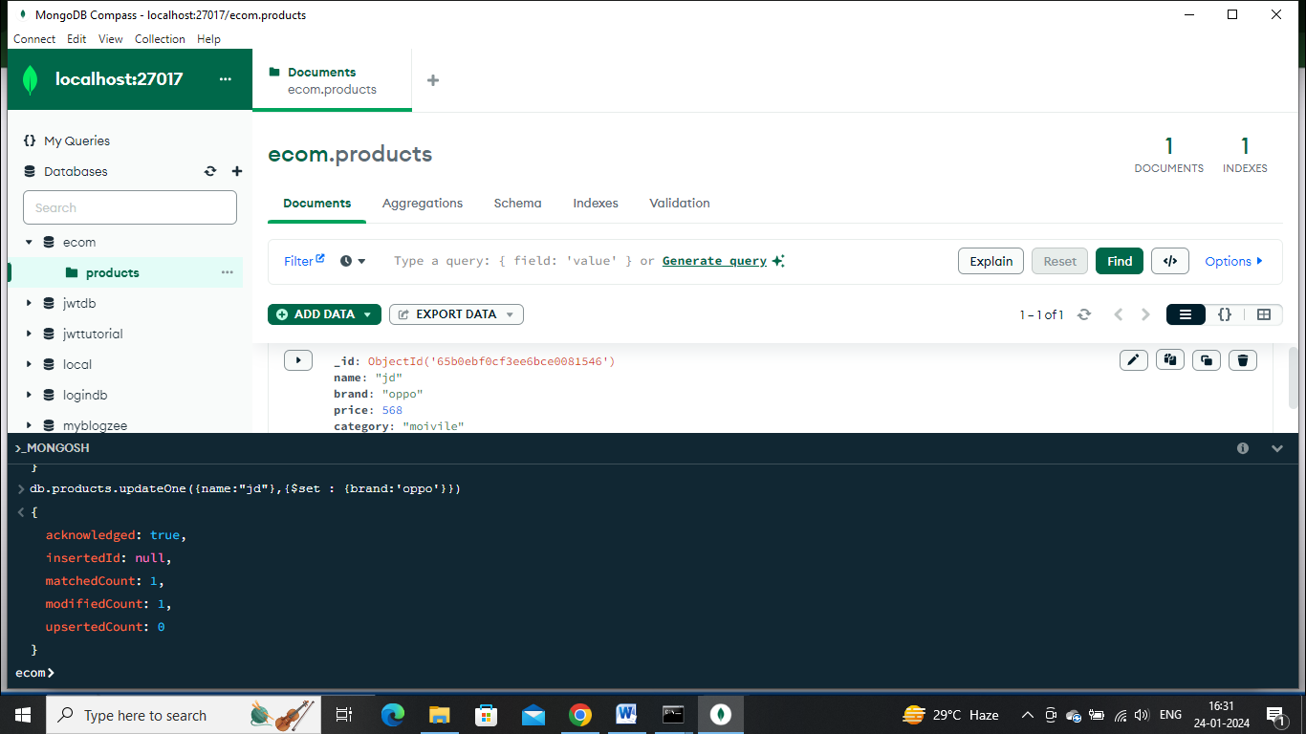

Delete:

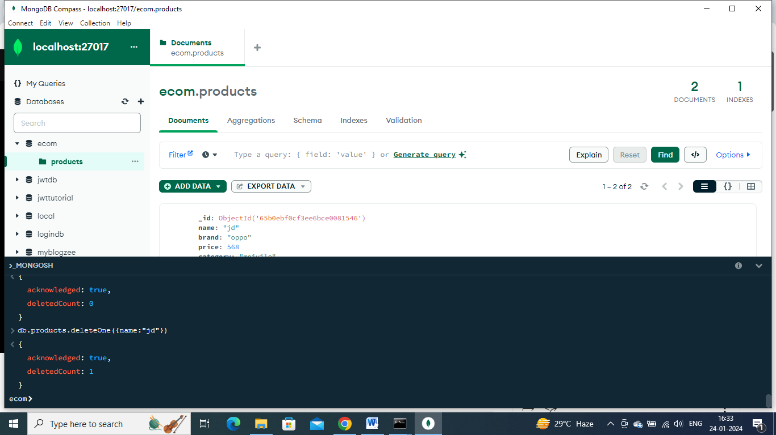

**Day 60: connecting mongodb with nodejs**

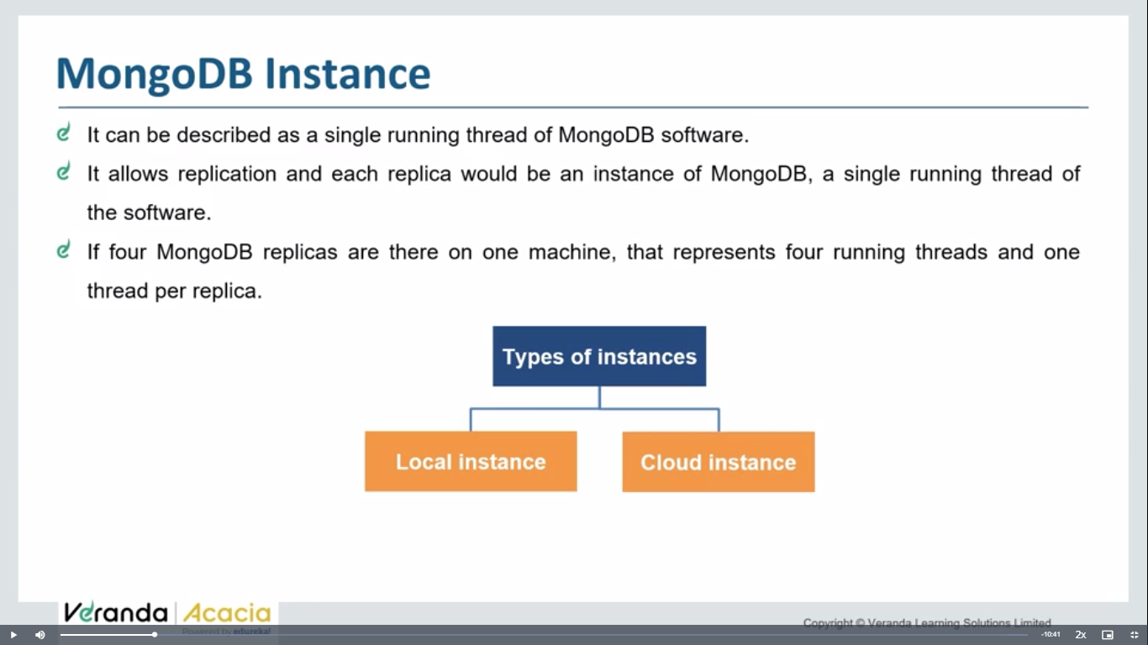 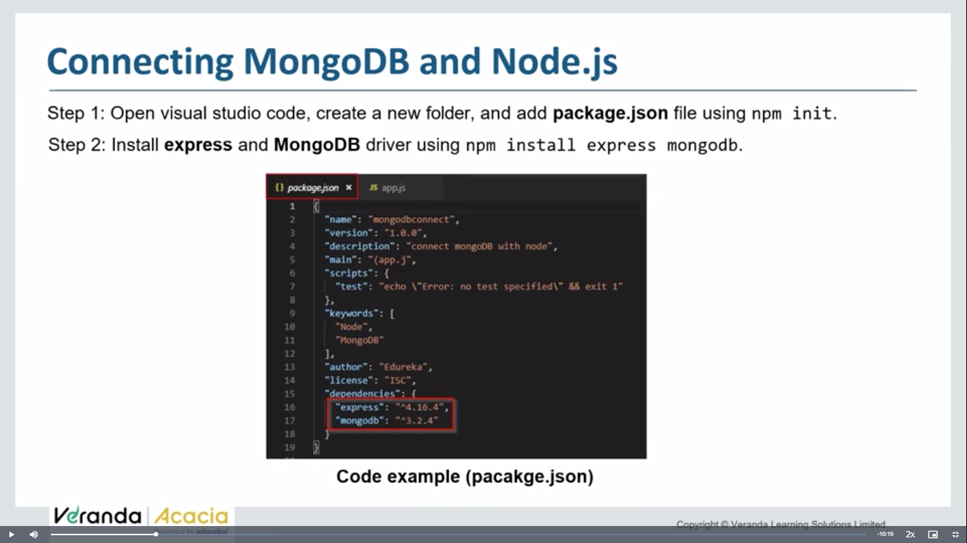 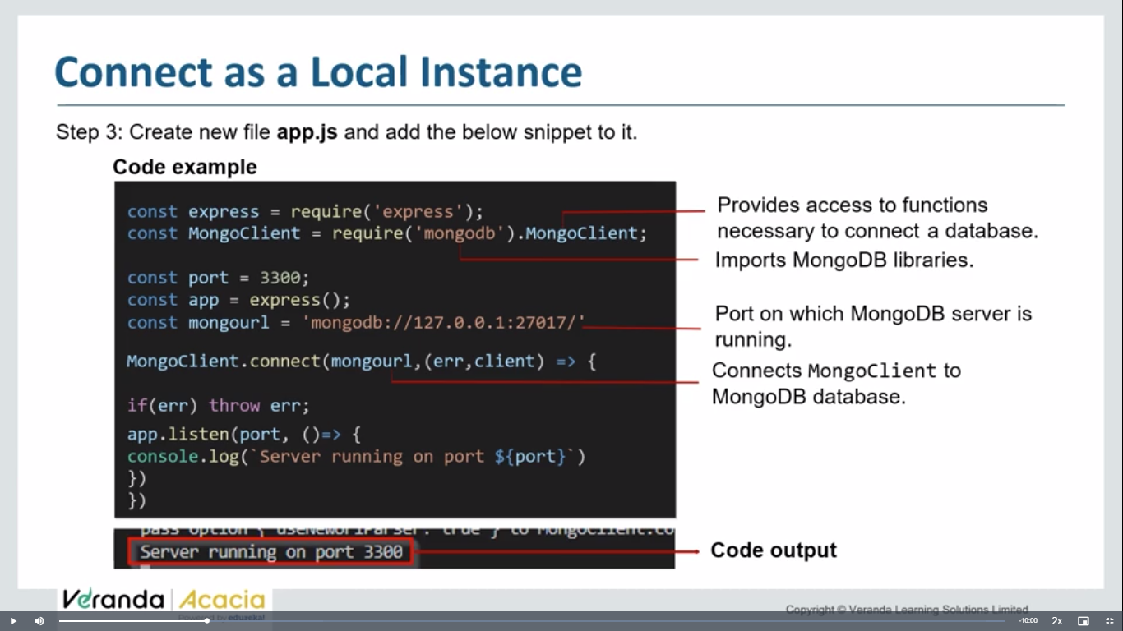 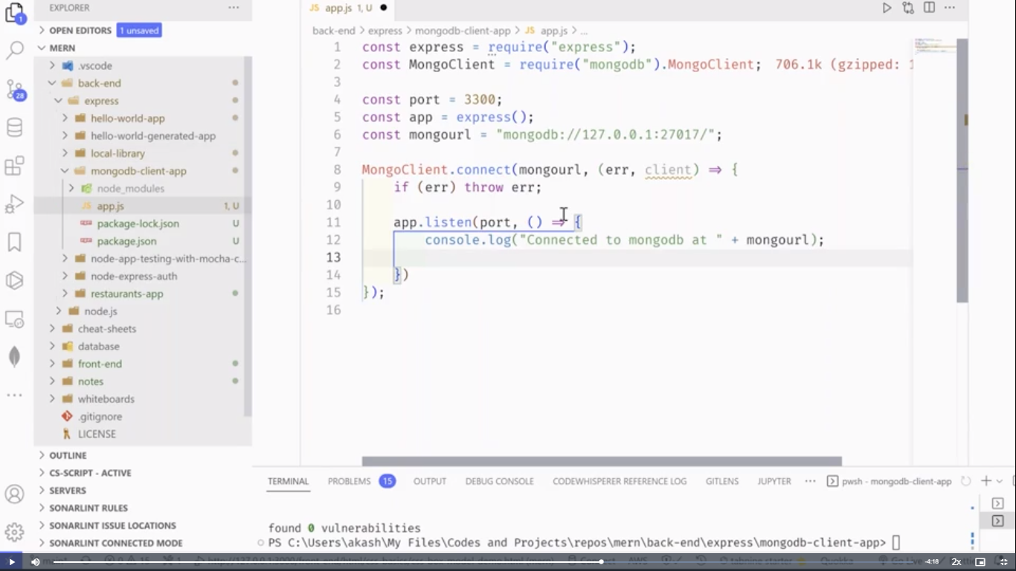

const express=require('express');

const mon=require('mongodb').MongoClient;

const host='mongodb://localhost:27017/databse ';

const app=express();

// const database1='Akdb'

// const client=new mon(host);

function one(){

    const var1=new mon(host).connect();//.connect is to connect host and MongoClient

    // const data=var1.db(database1);

    console.log('database connected');

    // const collect=data.collection('pandu');

    // console.log(collect);

}

one();

app.listen(3005, ()=>{

    console.log("server started on ports");

});

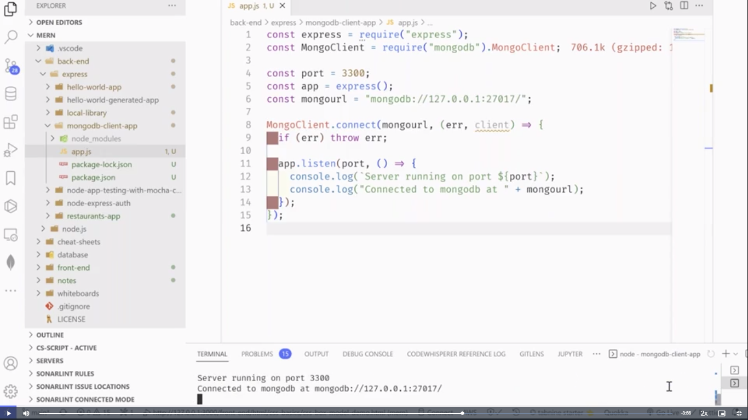 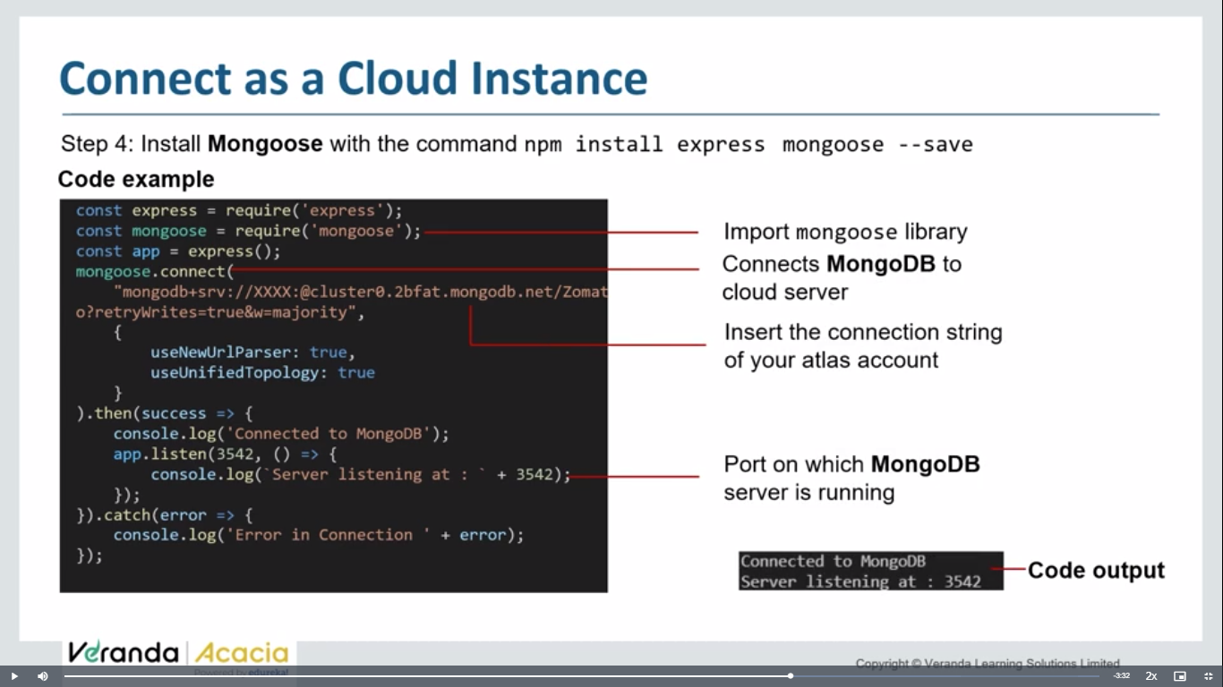 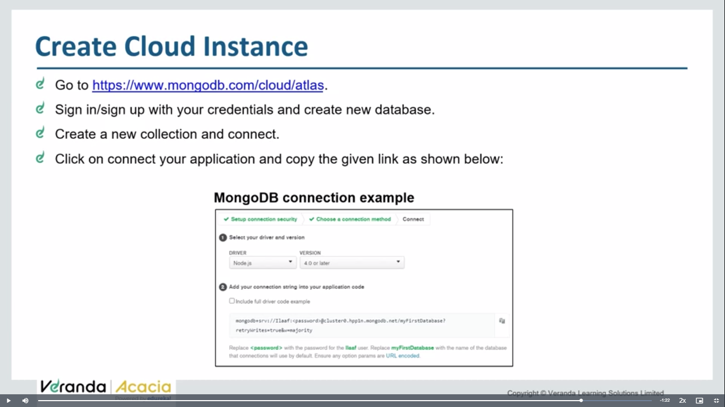

Npm I mongoose

const express=require('express');

const mongoo=require('mongoose');

const app=express();

app.listen(3542, ()=>{

    console.log('server started on ports');

});

mongoo.connect('mongodb://localhost:27017/cloudconn')

    .then(()=>console.log('mongoose connected'))

    .catch((err)=>console.log('err:'+err));

It wont display the db in mongodb compass until and unless , a collection is added into it.

Signup and register for mongodb atlas- <https://www.mongodb.com/cloud/atlas/register>

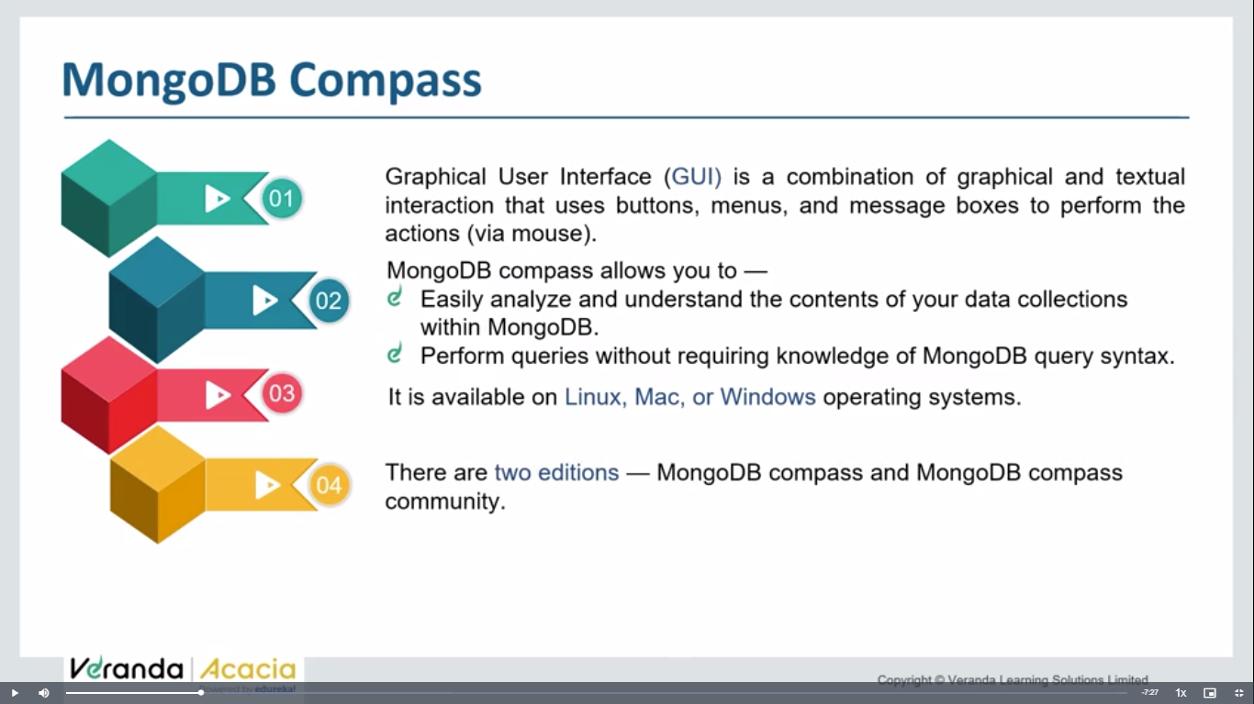

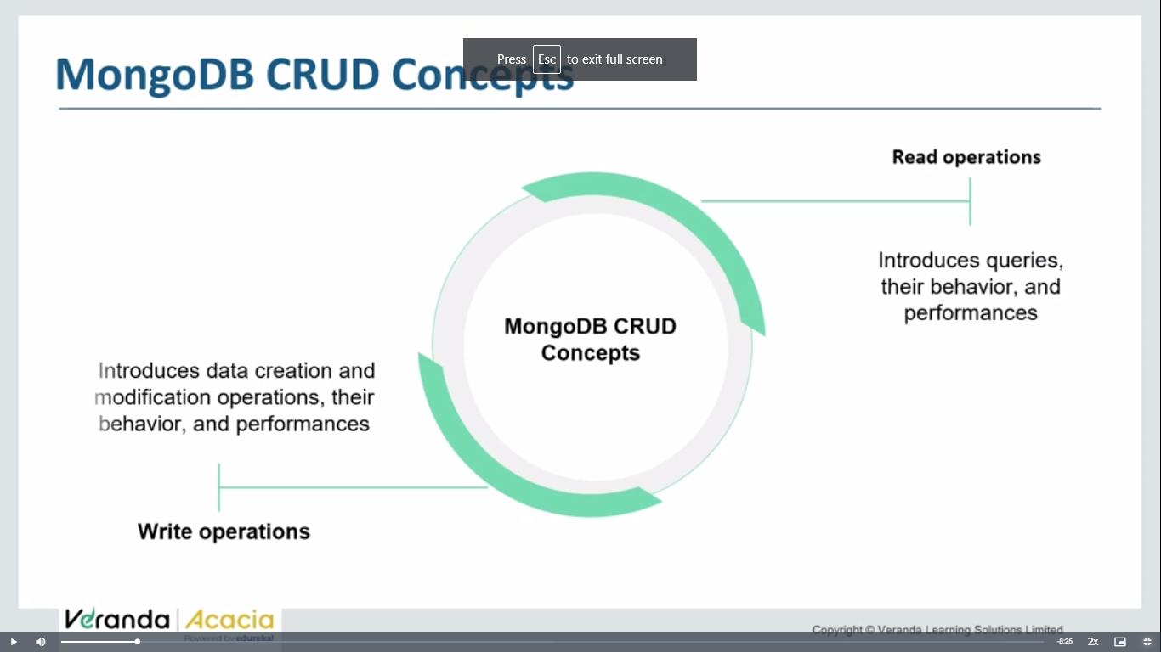 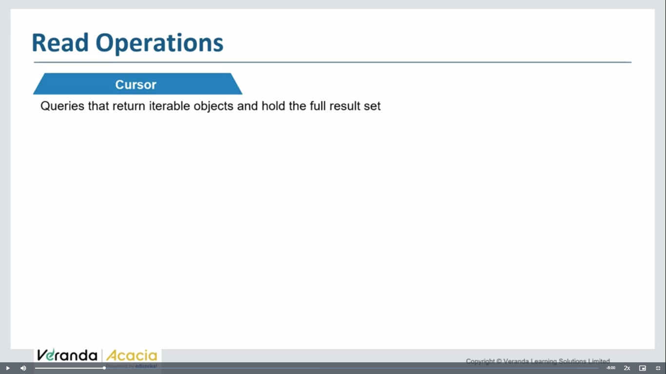

Whenever, u perform a find operation , it returns a iterable obj – which contains address of all records which included in result ser of query

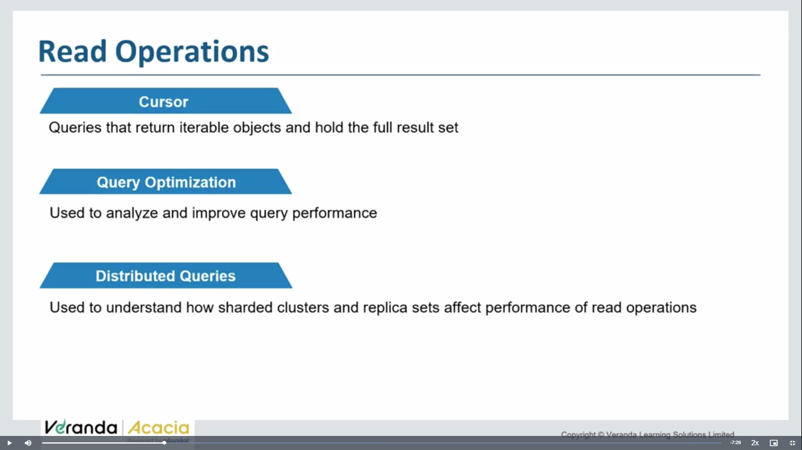

Distributed queries – when data shored on multiple physical db servers .

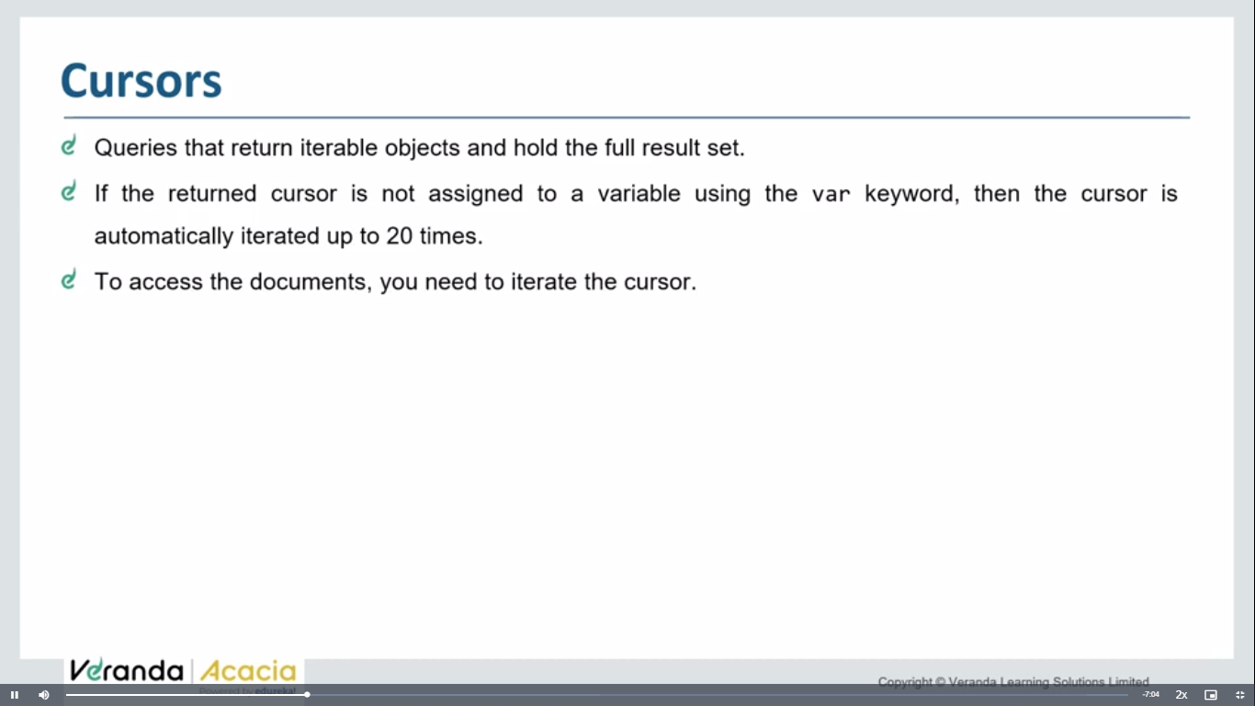

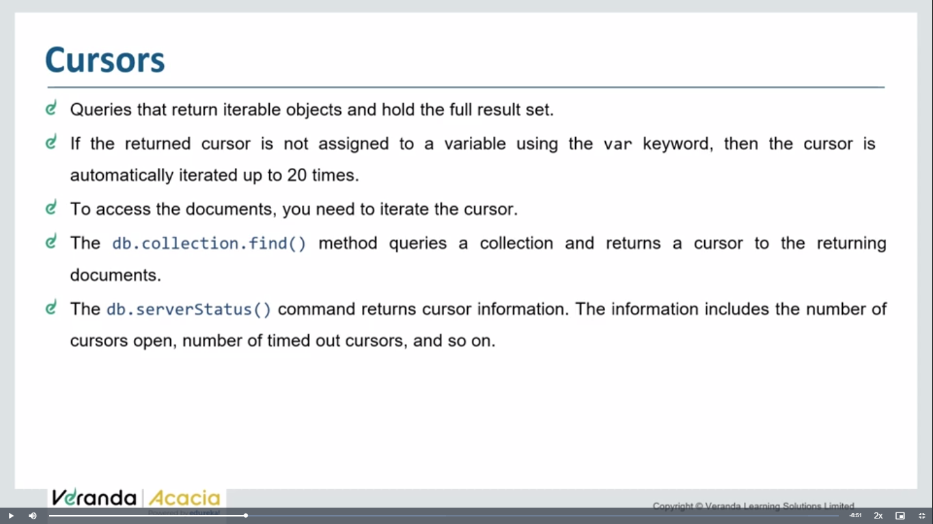 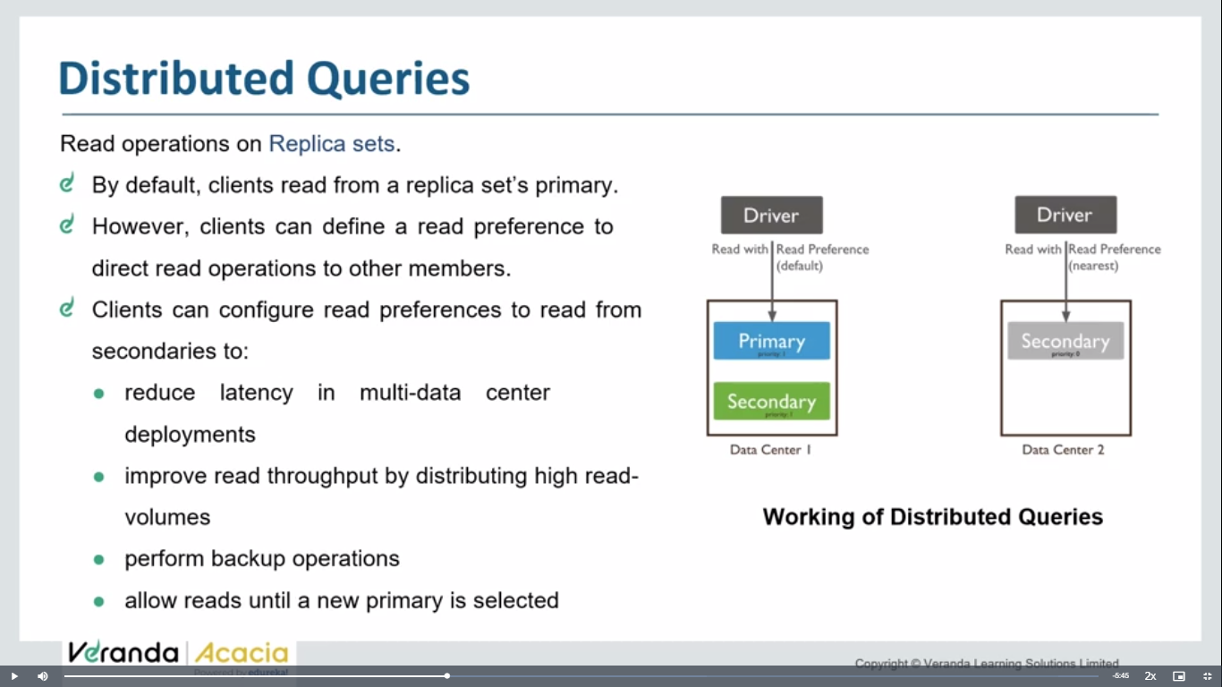 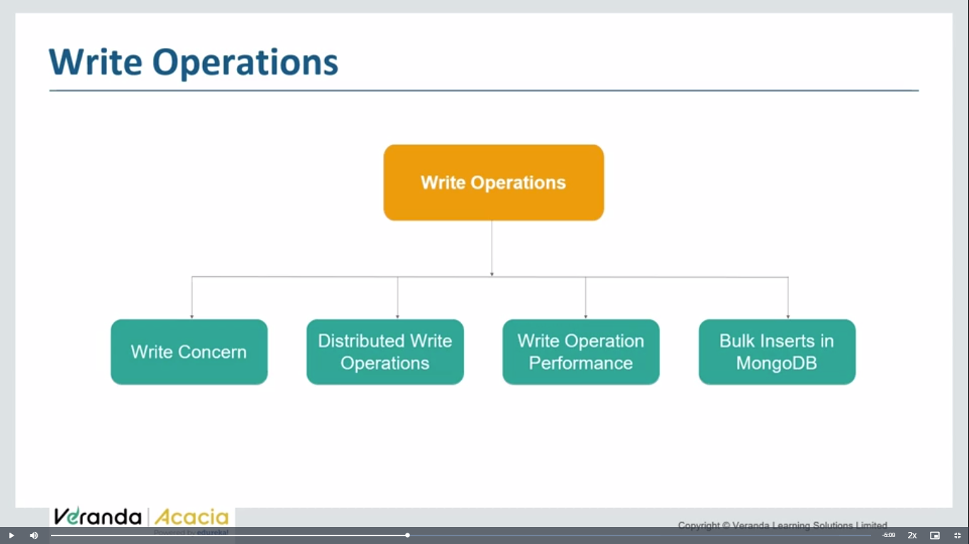 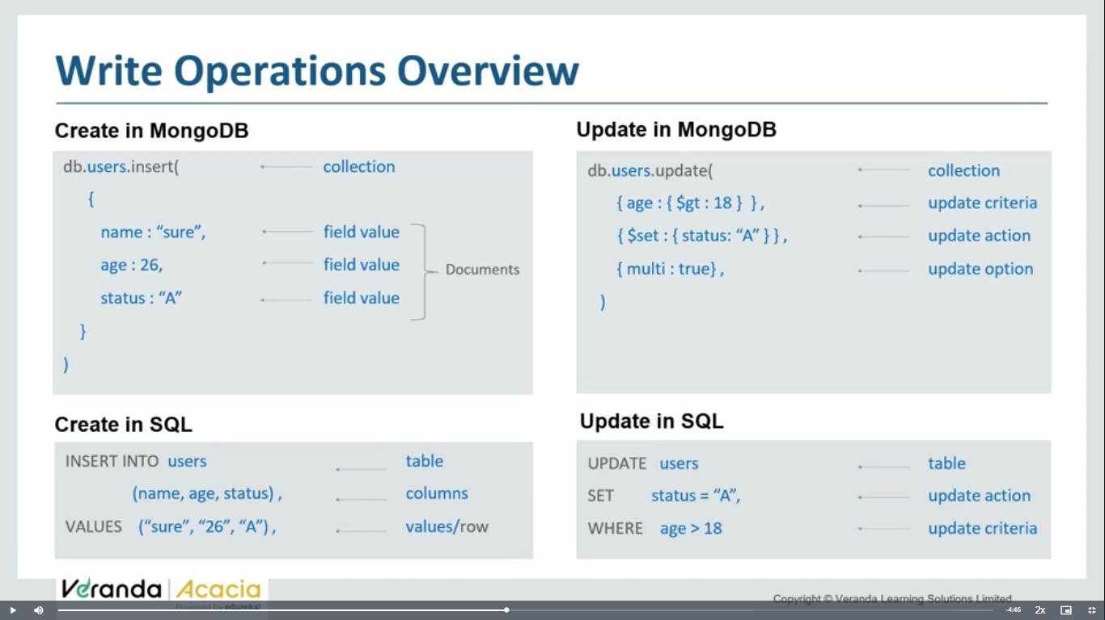 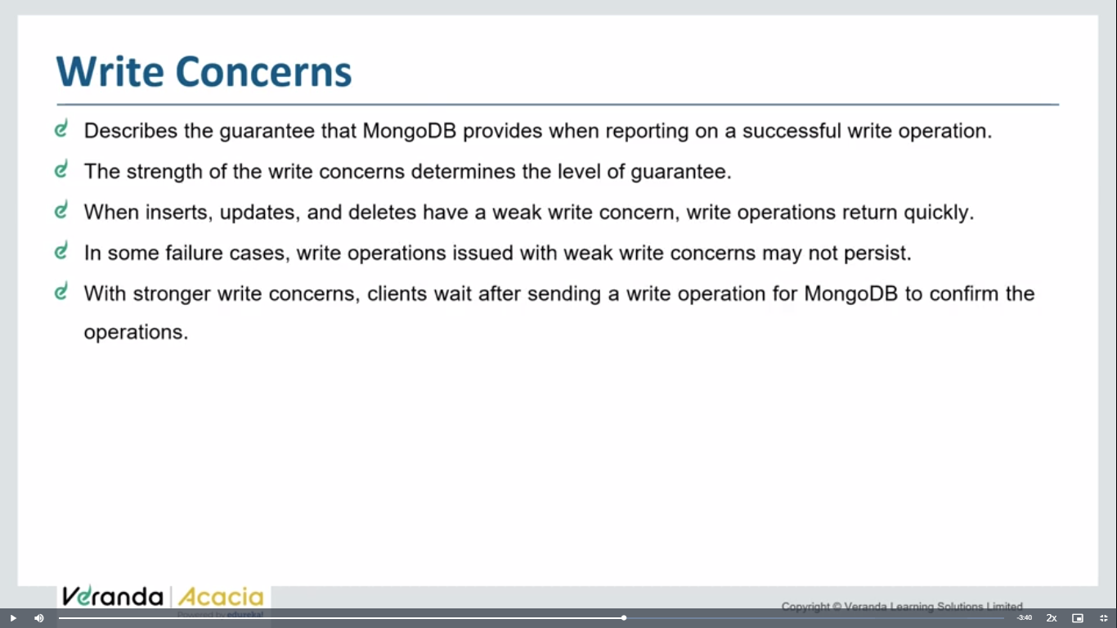 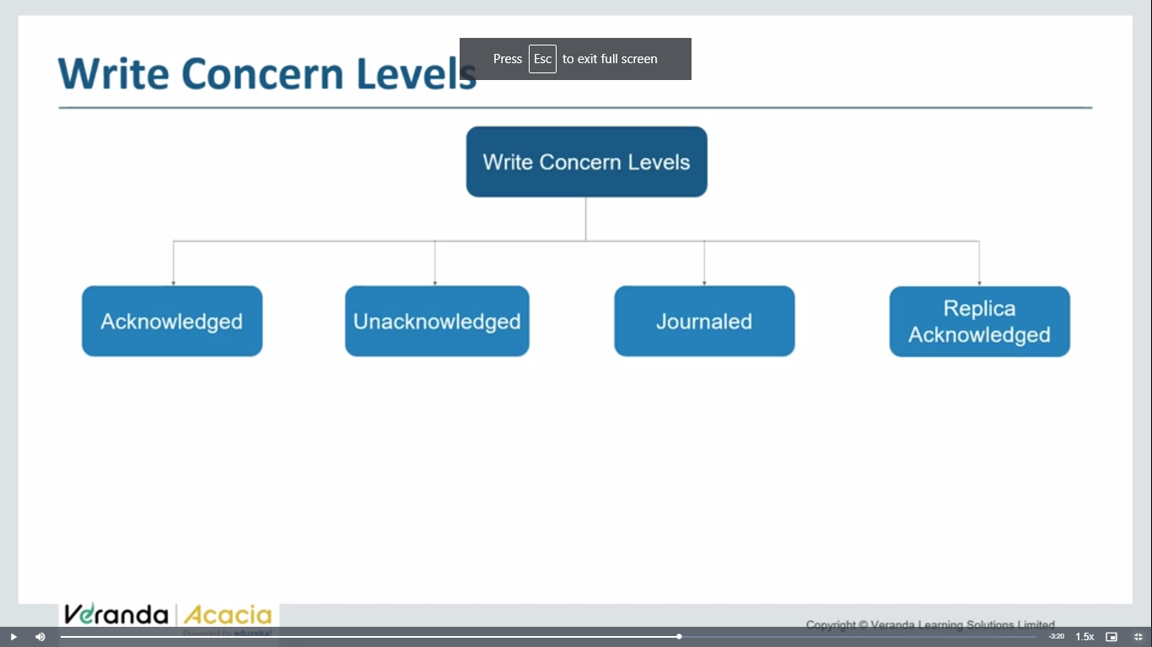

Ack- operation performed

Unack- we don’t know the status of operation

Journaled- log of operation

Replica ack- if u have replica sets – operations applied on all replica sets

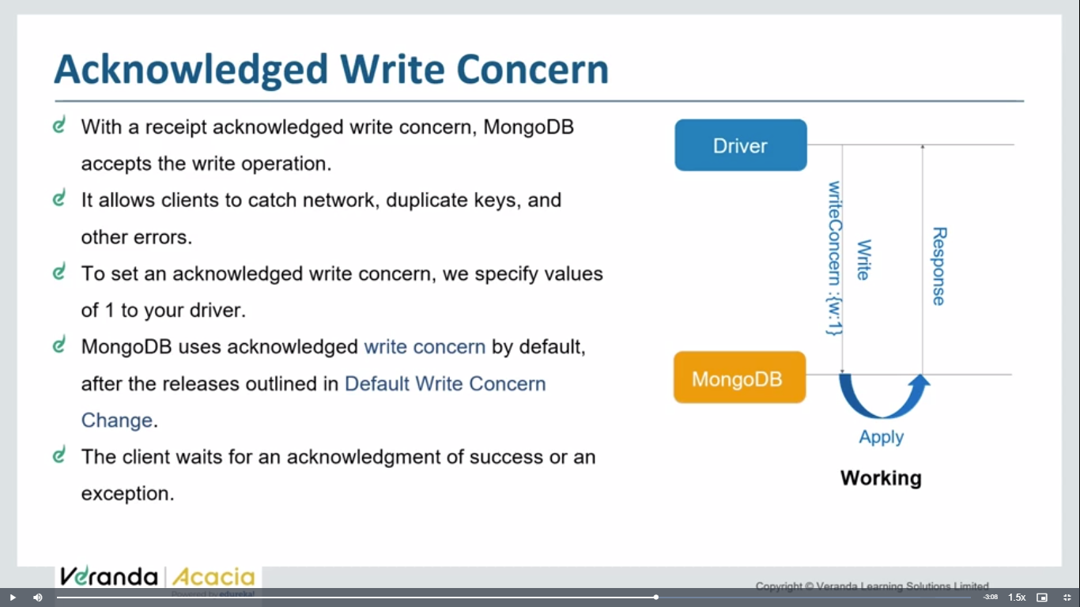 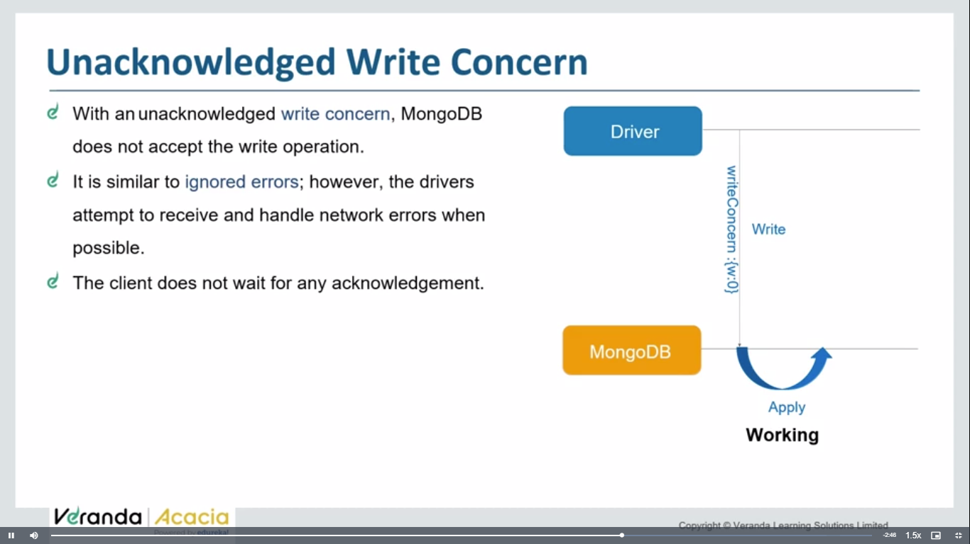 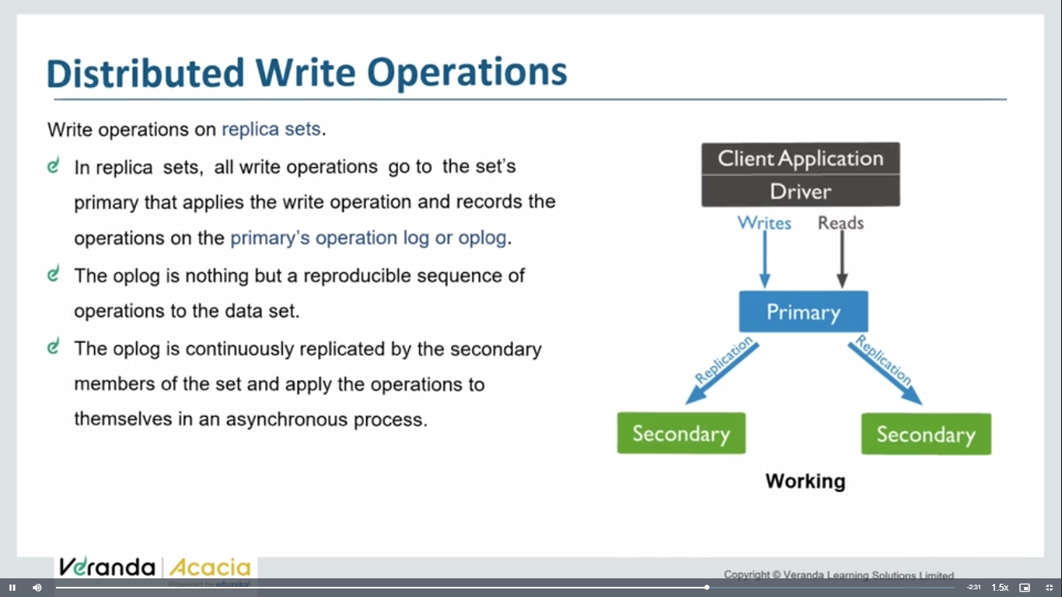 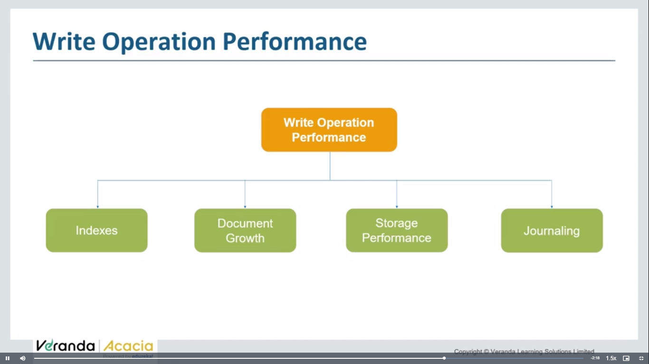 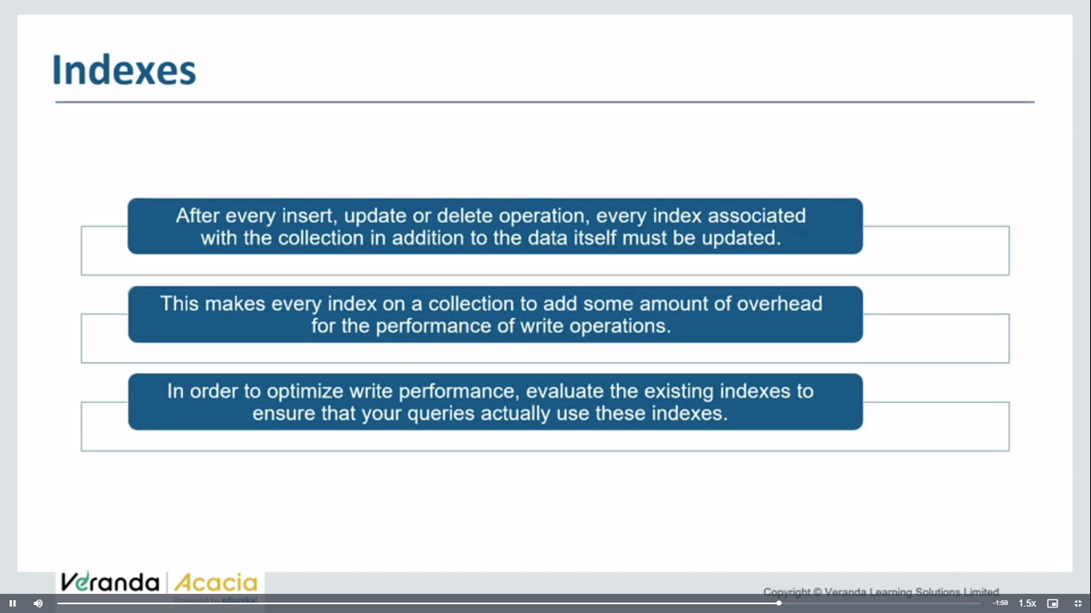hash table type of index

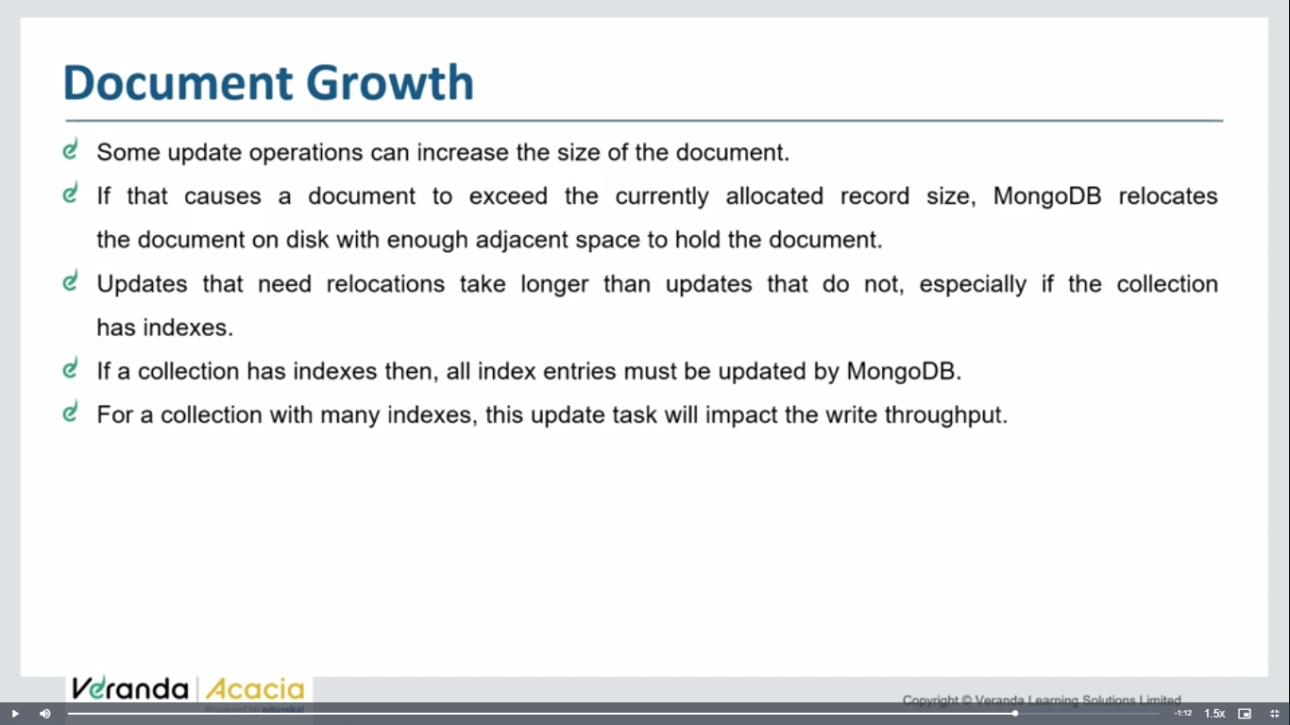

Do not let to increase no of indices increase too many

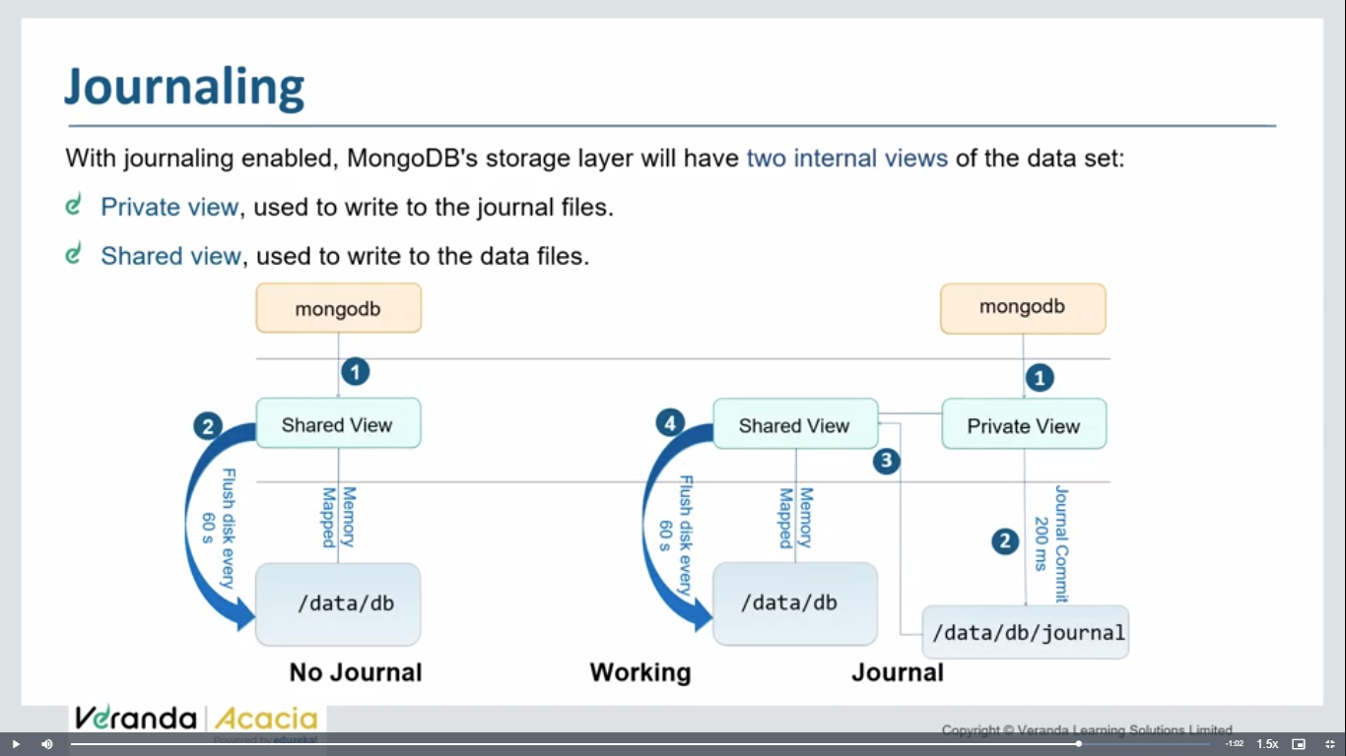

**Creating shcema and model:**

const express=require('express');

const app=express();

const mongoose=require('mongoose');

const connectdb=async()=>{

    try{

        await mongoose.connect("mongodb://localhost:27017",{

            dbName:"dbzeenath",

        })

        console.log("Connected to MongoDB")

    }

    catch(err){

        throw new Error("Couldn't connect to MongoDB")

    }

}

connectdb();

app.listen(3000,()=>{

    console.log('server started')

})

**Creating schema for column or field names:** we can create schema using mongoose.schema() method

const locSchema=mongoose.Schema({

    name:{

        type:String,

        required:true

    },

    city_id:{

        type:Number,

        required:true,

        unique:true

    },

    location_id:{

        type:Number,

        required:true,

        unique:true

    },

    city:{

        type:String,

        required:true

    },

    country_name:{

        type:String,

        required:true

    }

})

now after creating schema, model will be created out of it, after creting a model, a collection/table will be created in mongodb.

Model / collection can be created using mongoose.model()

const locModel=mongoose.model('location',locSchema)

**index.js**

const express=require('express');

const app=express();

const mongoose=require('mongoose');

const connectdb=async()=>{

    try{

        await mongoose.connect("mongodb://localhost:27017",{

            dbName:"dbzeenath",

        })

        console.log("Connected to MongoDB")

    }

    catch(err){

        throw new Error("Couldn't connect to MongoDB")

    }

}

connectdb();

const locSchema=mongoose.Schema({

    name:{

        type:String,

        required:true

    },

    city_id:{

        type:Number,

        required:true,

        unique:true

    },

    location_id:{

        type:Number,

        required:true,

        unique:true

    },

    city:{

        type:String,

        required:true

    },

    country_name:{

        type:String,

        required:true

    }

})

const locModel=mongoose.model('location',locSchema)

app.listen(3000,()=>{

    console.log('server started')

})

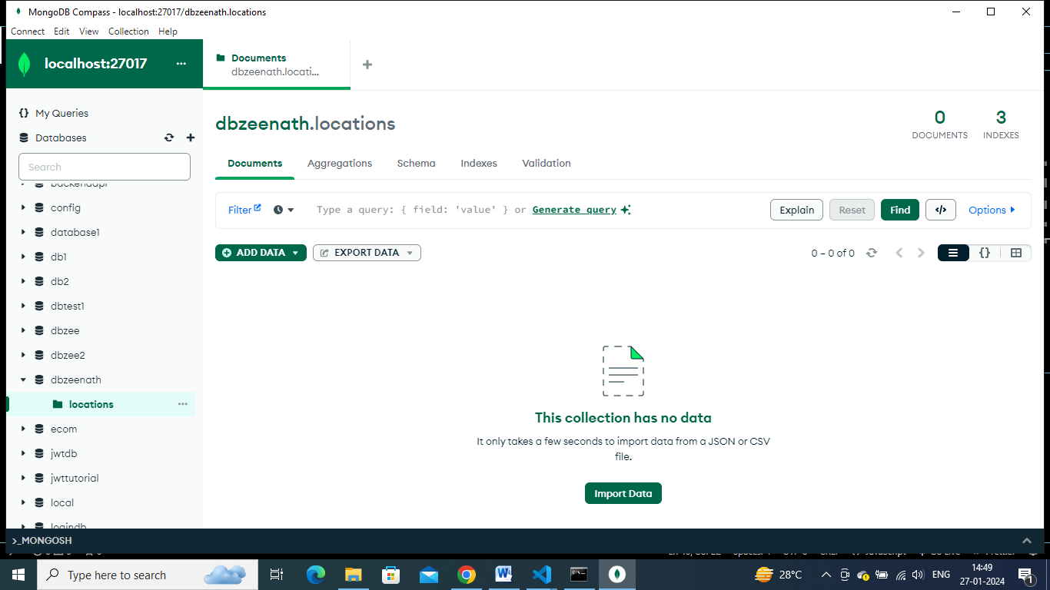

**CRUD operations with mongoose:**

We can even write mongoose.connect() inside a async function, as connection takes time

const mongoose=require('mongoose');

const main=async()=>{

    await mongoose.connect("mongodb://localhost:27017/databasetut");

    const schema1=mongoose.Schema({

        name:String

    })

    const model1=mongoose.model('table',schema1);

}

**Inserting new data:**

Creating data and saving it using save() method

const express=require('express');

const app=express();

const mongoose=require('mongoose');

const main=async()=>{

    await mongoose.connect("mongodb://localhost:27017/databasetut").then(()=>{

        console.log('db connected')

    });

    const schema1=mongoose.Schema({

        name:String

    })

    const model1=mongoose.model('table',schema1);

    let data=new model1({name:"zeenath"}); //creating new data

    let result=await data.save(); //saving into db

    console.log(result)

}

main()

app.listen(3000,()=>{

    console.log('server started')

})

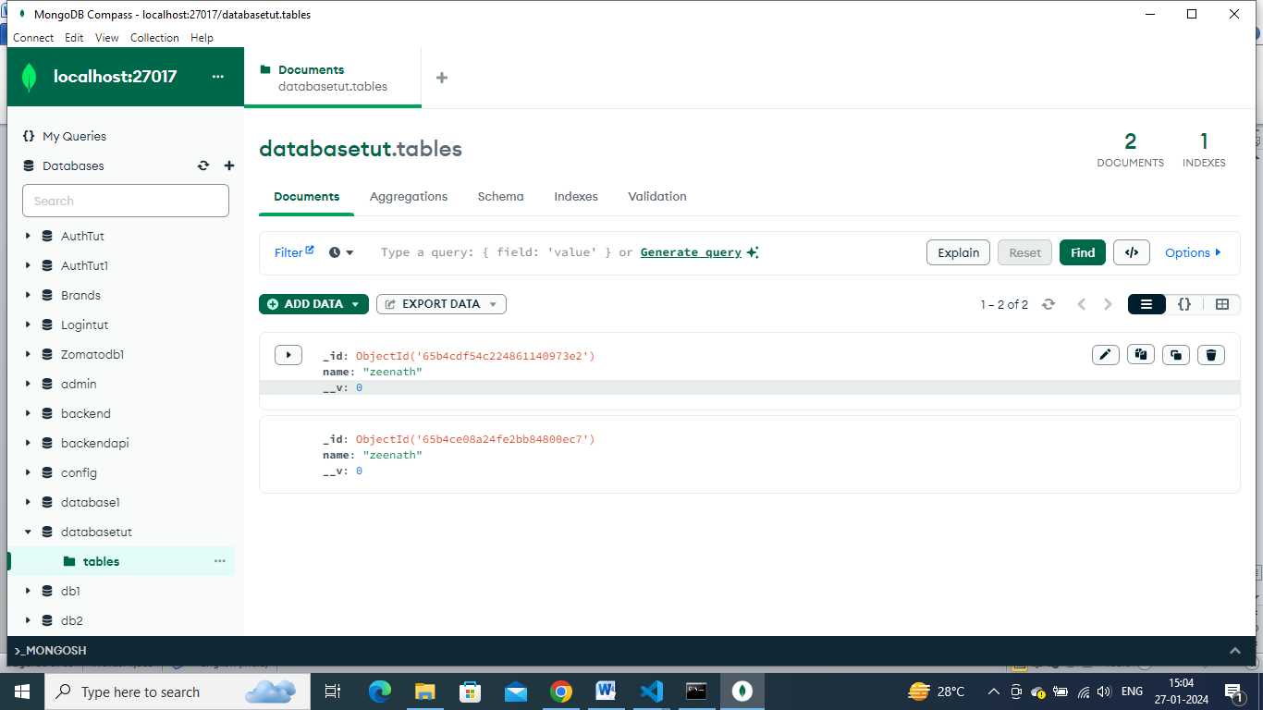

    let data=new model1({name:"zeenath",age:"78"});

try to add one more column/field age… this field is not mentioned in schema. ….so it not got stored.

If we edit schema like this,

    const schema1=mongoose.Schema({

        name:String,

        age:Number

    })

Then it will store age also in db

Like this we can add validations on schema.

Try to give only age, not name.

    let data=new model1({age:"78"});

then it stores only age into db

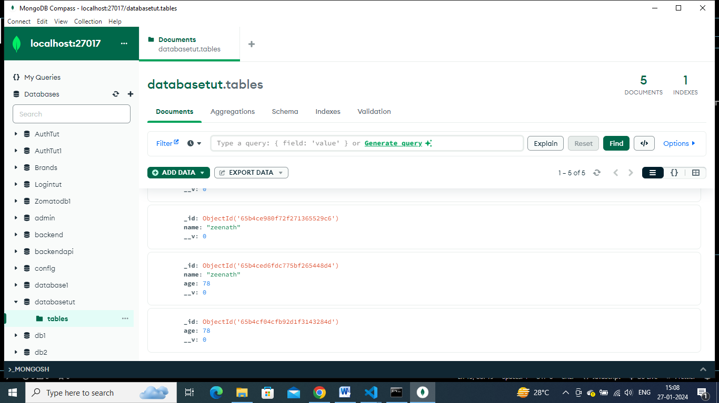

So entering age without name is not a valid thing, so u can add extra validations like name must be entered mandatory. As required:true

    const schema1=mongoose.Schema({

        name:{

            type:String,

            required: true,

        },

        age:{

            type:Number

        }

    })

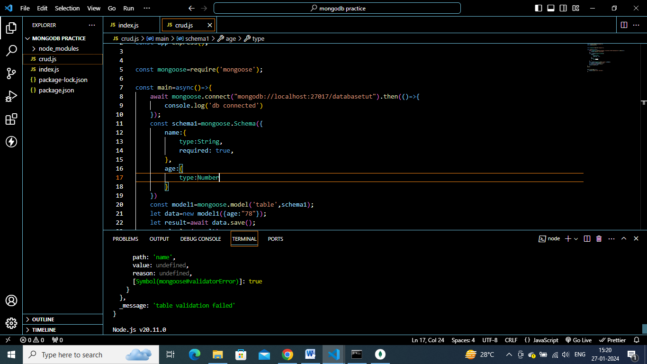

See now on entering only age, we got table validation failed error

    let data=new model1({

        name:'zeenath',

        age:"78"

    });

The name and age string in schema and the name and age keyword given while creating model should be same in case sensitive also , then only it will get stored into mongodb

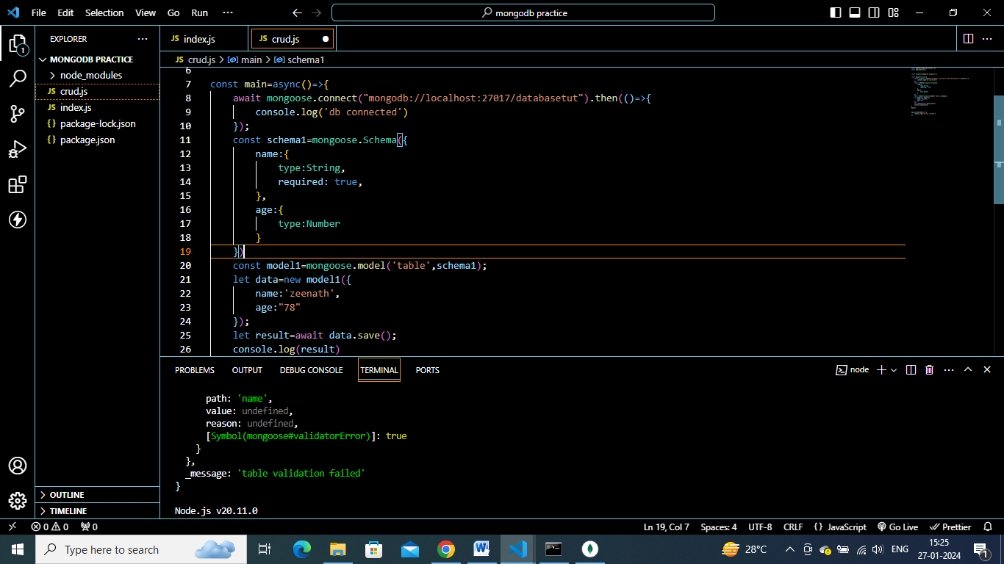

**Update opearation:**

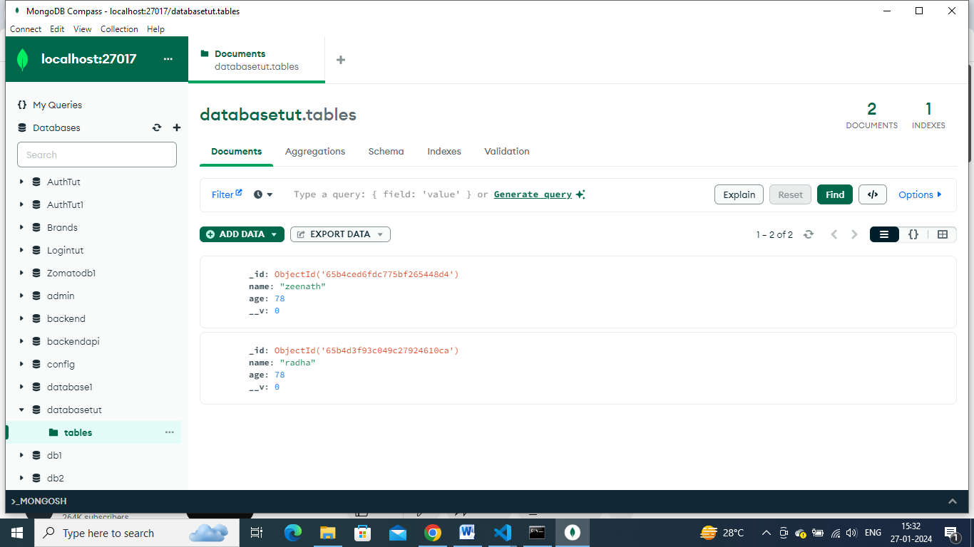

lets say,I want to change radha’s age to 56 .

then I can add update command to set age:56 where name=’radha’

const  updatefunc=async()=>{

    const model1=mongoose.model('table',schema1);

    let data=  await model1.updateOne(

        {name:"radha"},

        {

            $set:{age:56}

        }

    )

    console.log(data)

}

updatefunc()

crud.js

const express=require('express');

const app=express();

const mongoose=require('mongoose');

 mongoose.connect("mongodb://localhost:27017/databasetut").then(()=>{

    console.log('db connected')

});

const schema1=mongoose.Schema({

    name:{

        type:String,

        required: true,

    },

    age:{

        type:Number

    }

})

const main=async()=>{

    const model1=mongoose.model('table',schema1);

    let data=new model1({

        name:'zeenath',

        age:"78"

    });

    let result=await data.save();

    console.log(result)

}

main()

const  updatefunc=async()=>{

    const model1=mongoose.model('table',schema1);

    let data=  await model1.updateOne(

        {name:"radha"},

        {

            $set:{age:56}

        }

    )

    console.log(data)

}

updatefunc()

app.listen(3000,()=>{

    console.log('server started')

})

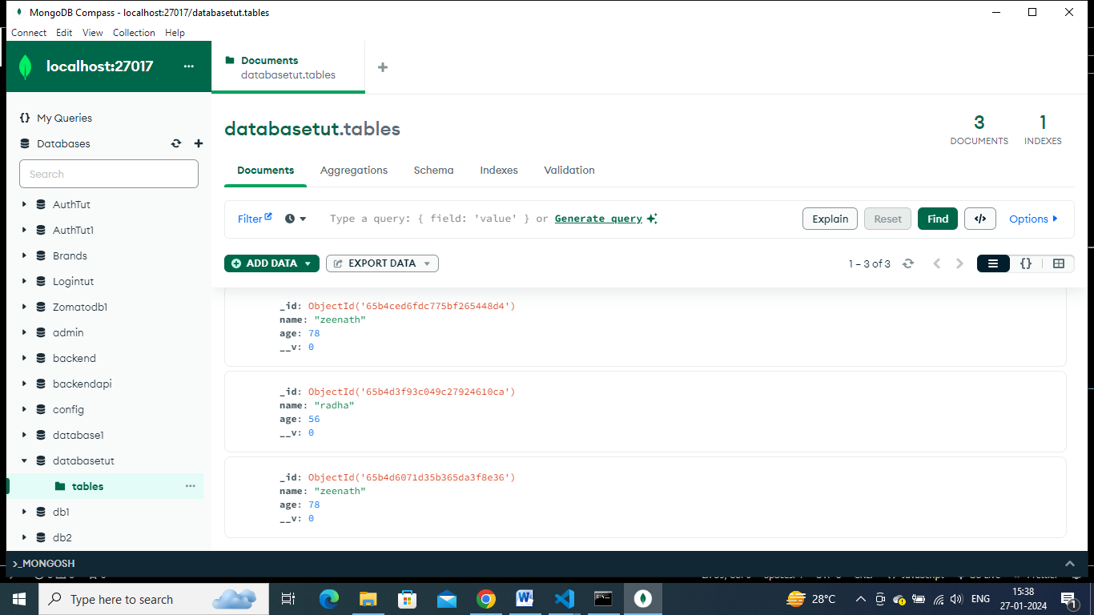

We can even change name and age

const  updatefunc=async()=>{

    const model1=mongoose.model('table',schema1);

    let data=  await model1.updateOne(

        {name:"radha"},

        {

            $set:{age:56, name:"radhika"}

        }

    )

    console.log(data)

}

updatefunc()

const deletefunc=async()=>{

    const model1=mongoose.model('table',schema1);

    let data=await model1.deleteOne({name:"america"})

    console.log(data)

}

deletefunc()

find operation – displaying all/some selected rows

displaying all rows – db.find()

const findfunc=async()=>{

    const model1=mongoose.model('table',schema1);

    let data=await model1.find();

    console.log(data)

}

findfunc()

to display only some columns based on some condition

dispay only those columns where name=radhika”

const findfunc2=async()=>{

    const model1=mongoose.model('table',schema1);

    let data=await model1.find({name:'radhika'});

    console.log(data)

}

findfunc2()

***post api creation using mongoose:***

**creating post route,** taking input from user from postman, and saving data into db

previously we done static crud operations , now by taking input from postman, can create dynamic crud opearations.

Now we will create schema and model also in this to create perfect project level api.

**Config.js**

const mongoose=require('mongoose');

mongoose.connect('mongodb://localhost:27017/databasemongoose').then(()=>{

    console.log('database connected')

})

No need of doing export(module.exports) in config.js

In one database, we can have many number of collections, so for each collection – we need to create schemas and model.

Eg: for product details – we can create model and schema

For user details- we can create another model and schema

**Product.js:**

const mongoose=require('mongoose');

const ProductSchema=new mongoose.Schema({

    name: String,

    price:Number,

    brand:String,

    category:String

})

// const ProductSchema=new mongoose.Schema({

//     name: {

//         type:String,

//         required: true

//     },

//     price: {

//         type:Number,

//         required: true

//     },

//     brand:{

//         type:String,

//         required: true

//     },

//     category:{

//         type:String,

//         required:true

//     }

// })

module.exports=mongoose.model('products',ProductSchema)

so we created model using mongoose.model() method

in this we passed collection(table name) – as products and schemavariable as parameters.

**Index.js**

const express=require('express');

const app=express();

require('./config');

const product=require('./product');

app.get('/',(req,res)=>{

    res.send('hello page')

})

app.post('/create',(req,res)=>{

    res.send('done')

})

app.listen(3000,()=>{

    console.log('server started')

})

Now execute get command in browser, AND execute get and post command in postmanand check

Run the server and then check output -= nodemon index.js

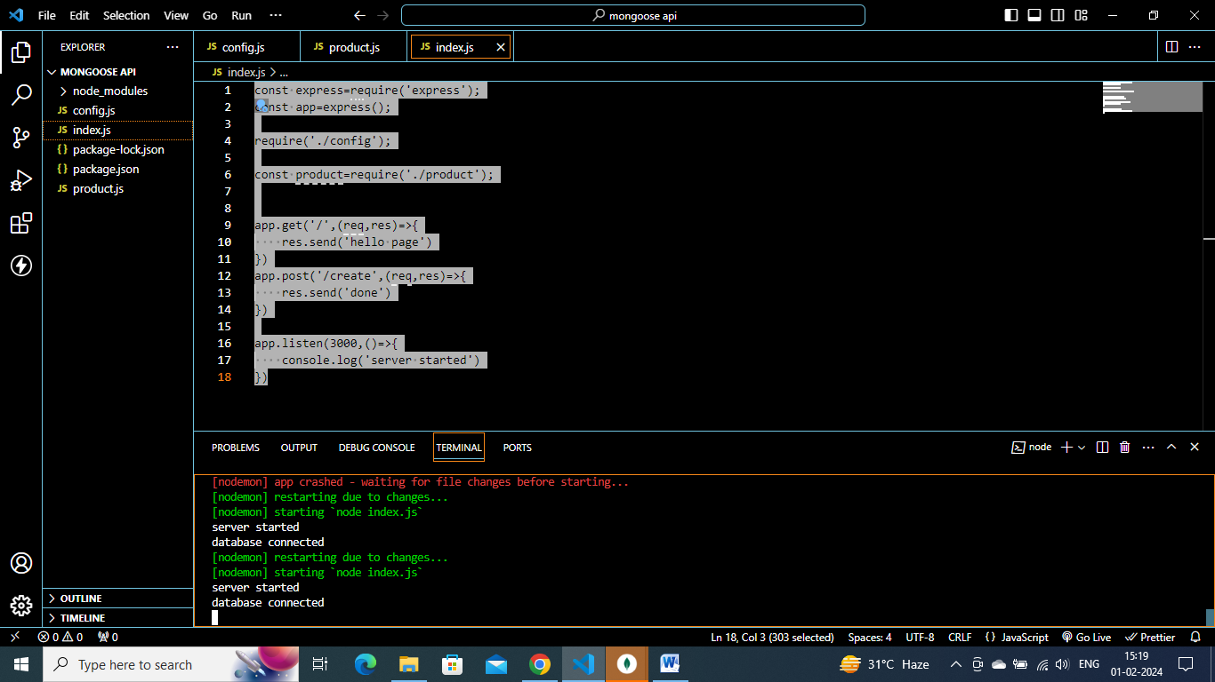

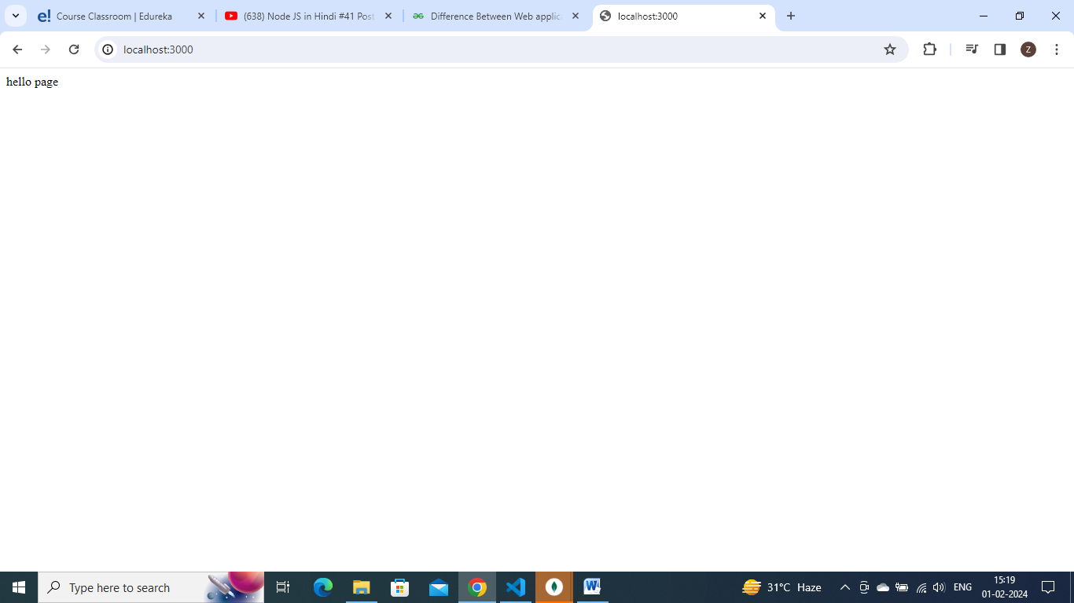

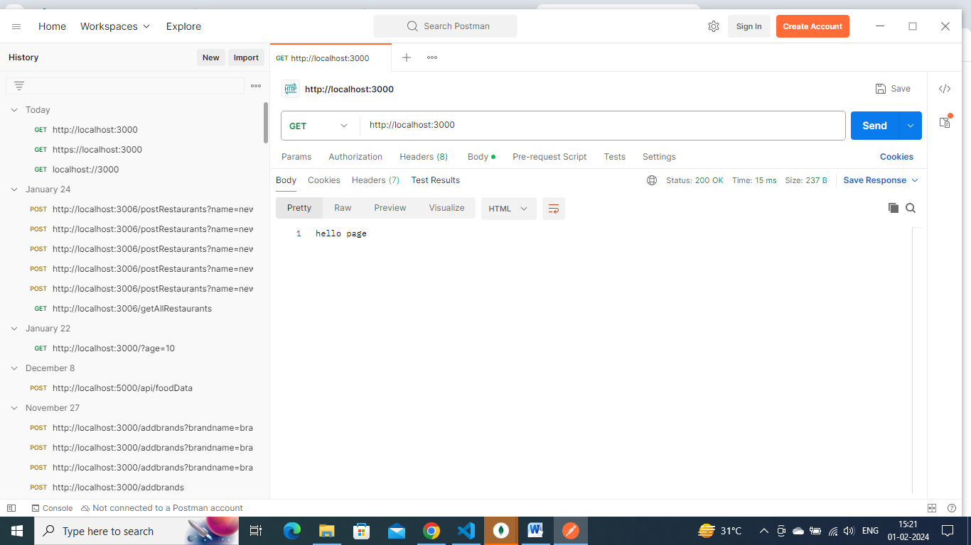

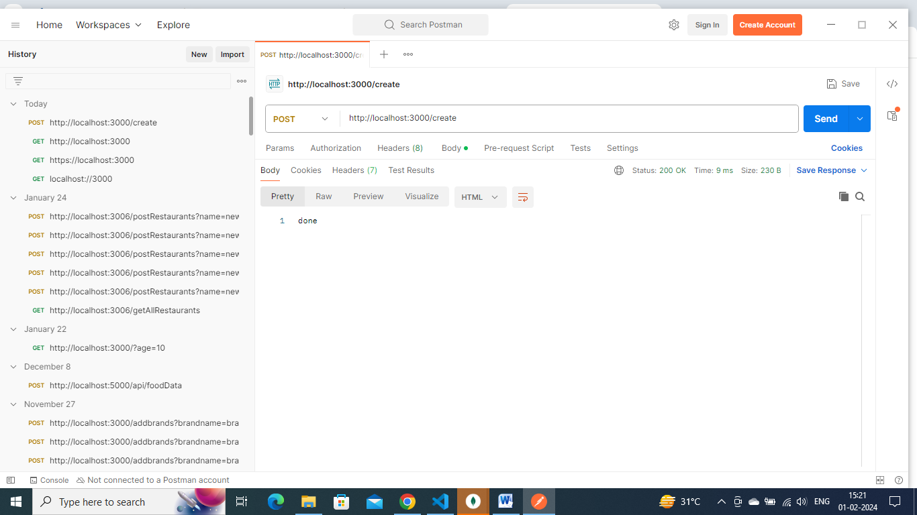

Here in post operation , we just sent a text as “done”

To send data

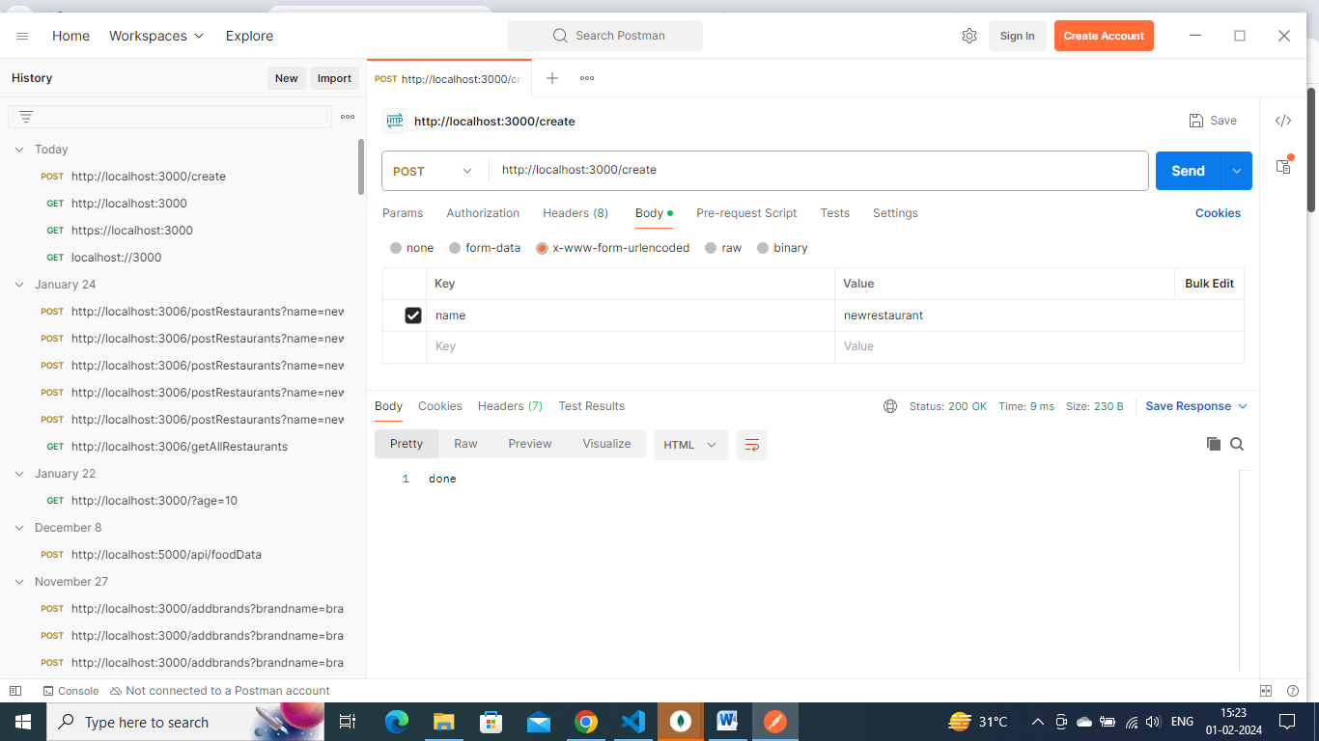

To send some data, in body we can give some key value pairs . selectinig “ body” tab and “x-www-form-urlencoded” , here we should give data in key value pairs.

To read or convert this key- value pairs data – we use

// app.use(express.urlencoded({extended:false}));

The other way, we can give data in json format

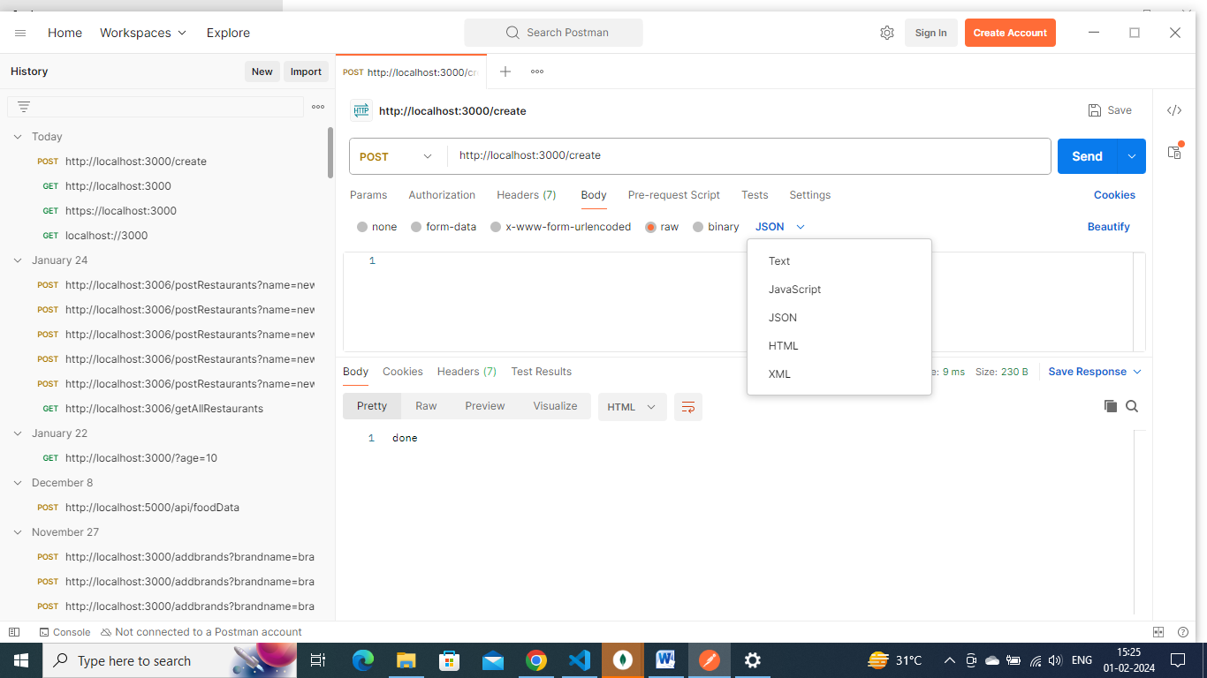

Select “raw” and json

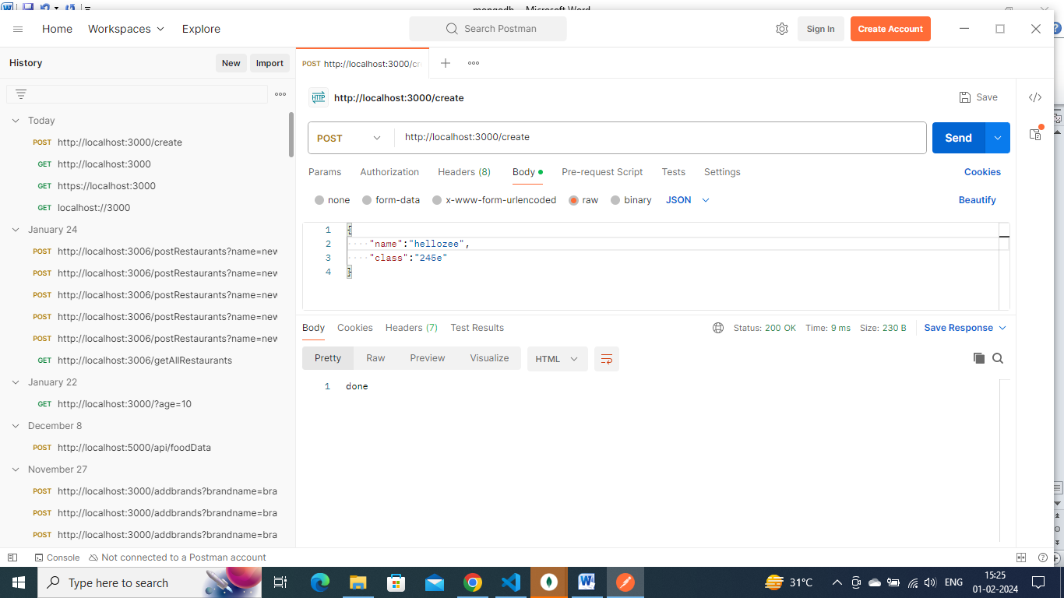

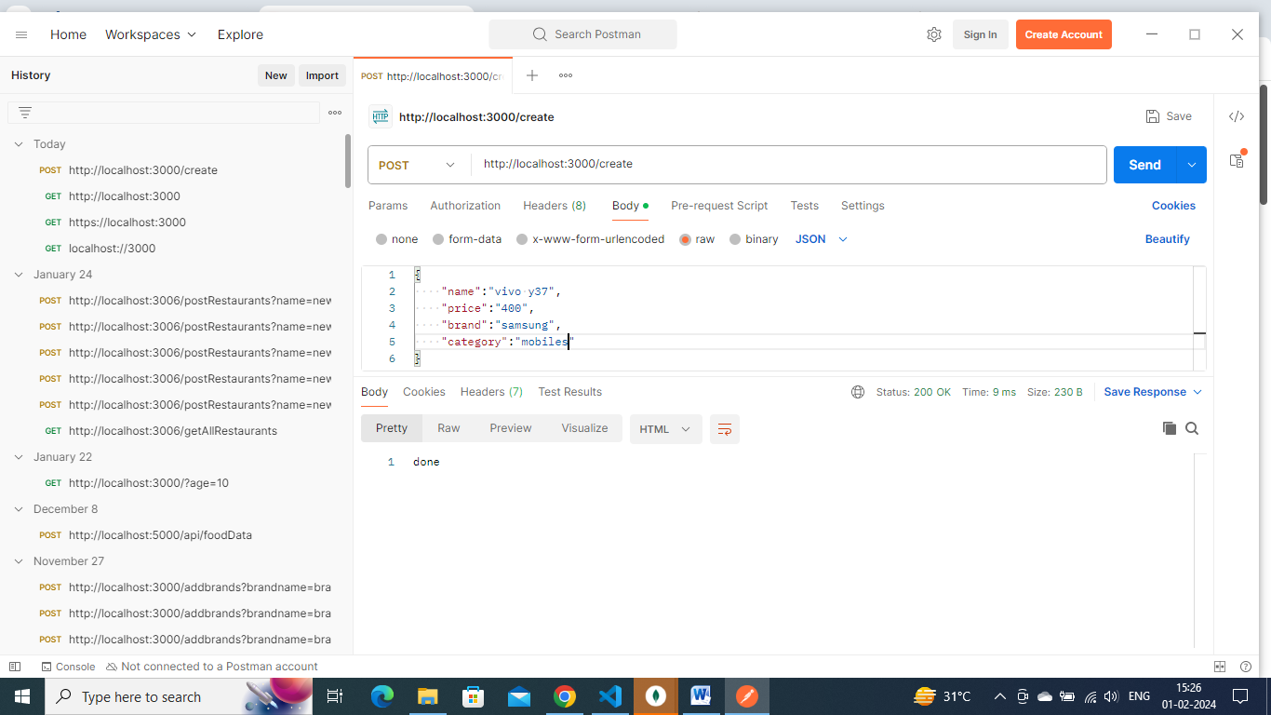

We can give in json format like this in {}

This data which we send here will be stored in req.body

This data will be in array stream format, we have to convert it into json using

app.use(express.json())

app.post('/create',(req,res)=>{

    console.log(req.body) // console.log(req.body) to display entered data in postman

    res.send('done')

})

Output:

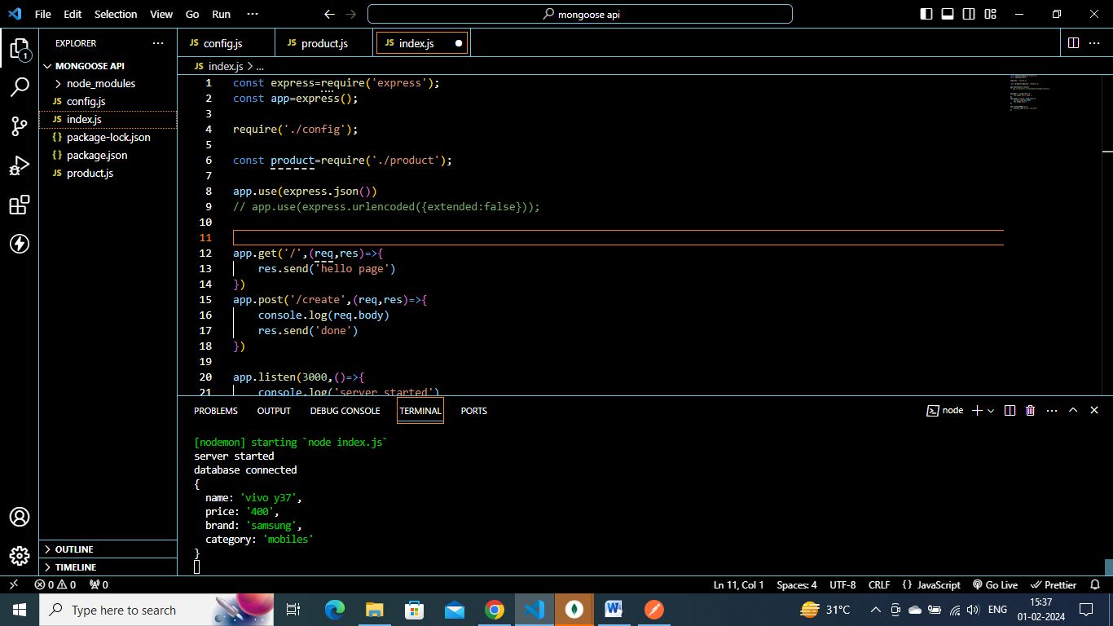

**Note:**

**For reading key- value form data – use below function**

**// app.use(express.urlencoded({extended:false}));**

const product=require('./product');

app.post('/create',async (req,res)=>{

    let data=new product(req.body);

    let result=await data.save()

    console.log(result)

    res.send(result)

})

**Creating a data and storing into db**

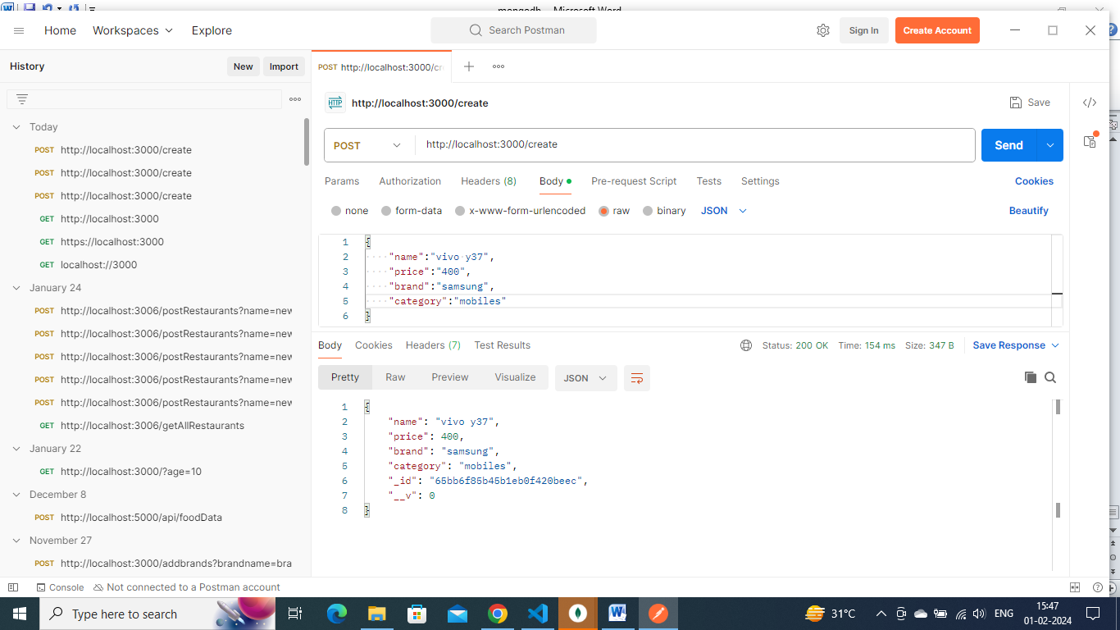

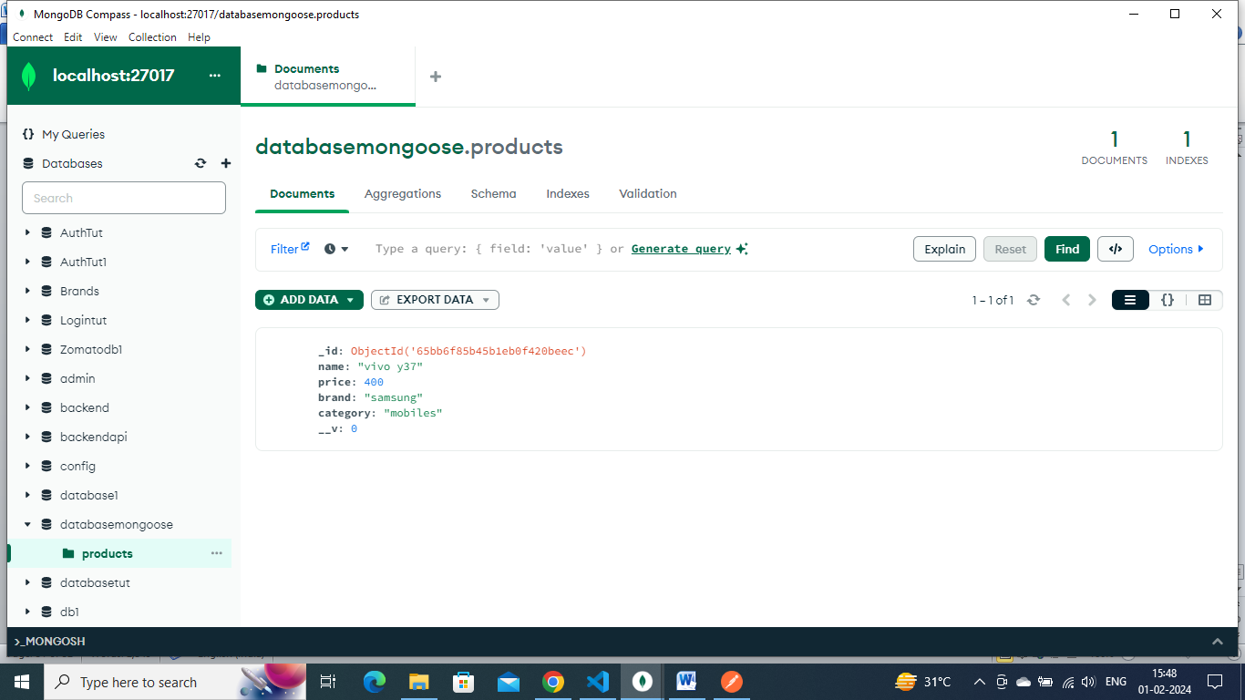

**So by using create() or save() method , we can store data into db**

The main difference between using the create and save methods in Mongoose is that create is a convenience method that automatically calls new Model() and save() for you, while save is a method that is called on a Mongoose document instance.

When you call the create method on a Mongoose model, it creates a new instance of the model, sets the properties, and then saves the document to the database. This method is useful when you want to create a new document and insert it into the database in one step. This makes the creation an atomic transaction. Therefore, the save method leaves the potential to create inefficiencies/inconsistencies in your code.

On the other hand, the save method is called on an instance of a Mongoose document, after you have made changes to it. This method will validate the document and save the changes to the database.

Another difference is that create method can insert multiple documents at once, by passing an array of documents as parameter, while save is intended to be used on a single document.

So, if you want to create a new instance of a model and save it to the database in one step, you can use the create method. If you have an existing instance of a model that you want to save to the database, you should use the save method.

app.post('/create',async (req,res)=>{

    //save method - done in 2 steps

    // let data=new product(req.body);

    //let result=await data.save()

    //create method done in 1 step

    let result=await product.create(req.body)

    console.log(result)

    res.send(result)

})

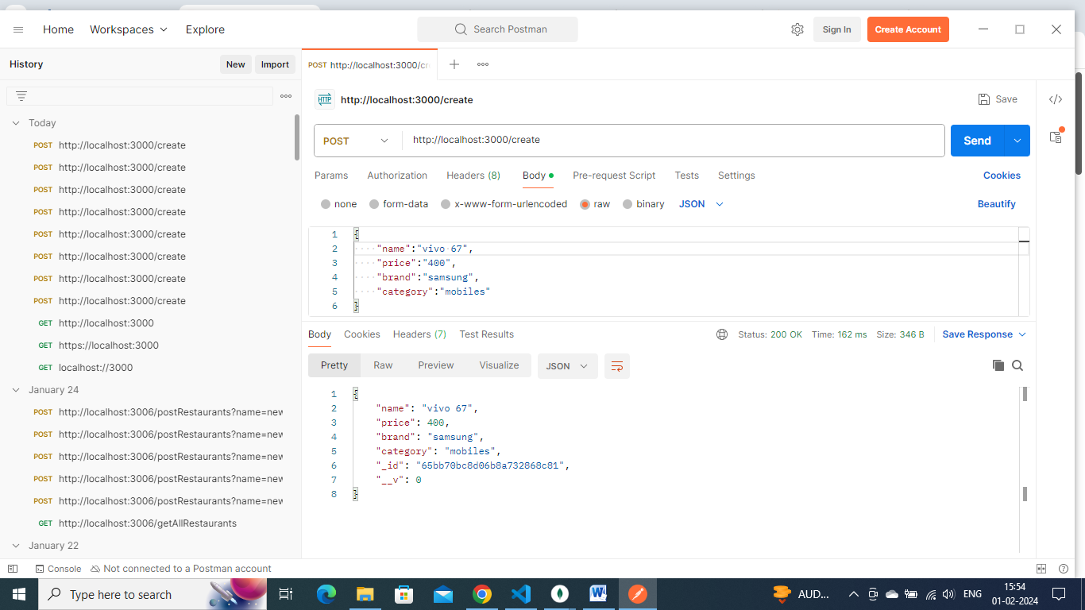

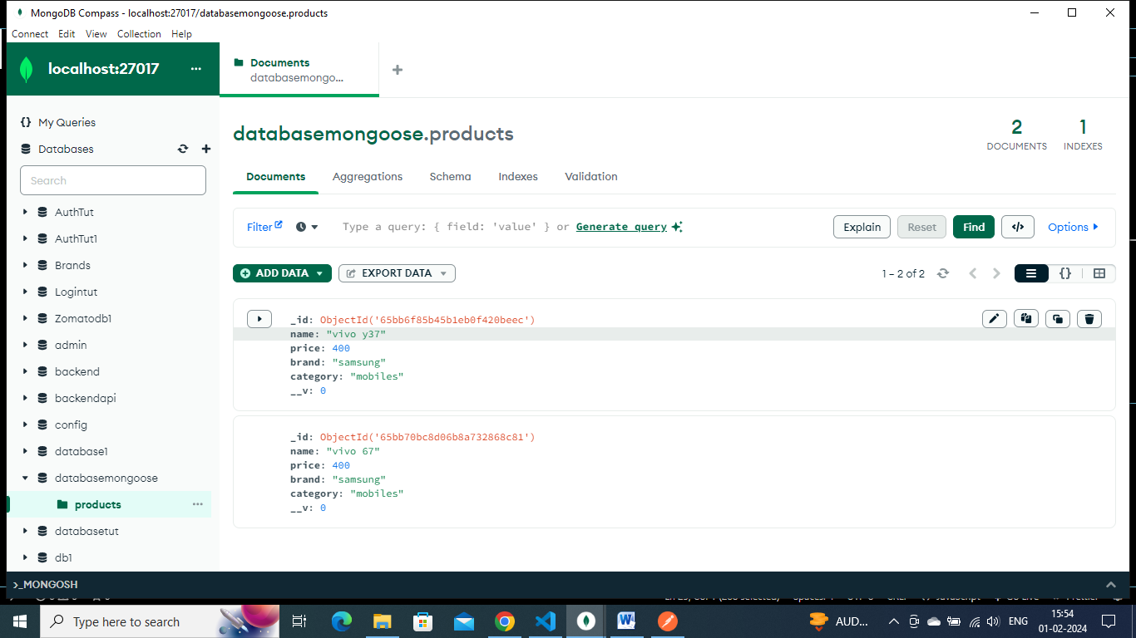

**Get, delete and put operation in mongodb:**

**Simple get method**

app.get('/',(req,res)=>{

    res.send('hello page')

})

**Technically in get method, we get all the data from mongodb , and we will display it .- for this we can use find() command of mongodb**

const product=require('./product');

app.get('/lists',async(req,res)=>{

    let data=await product.find();

    res.send(datas)

})

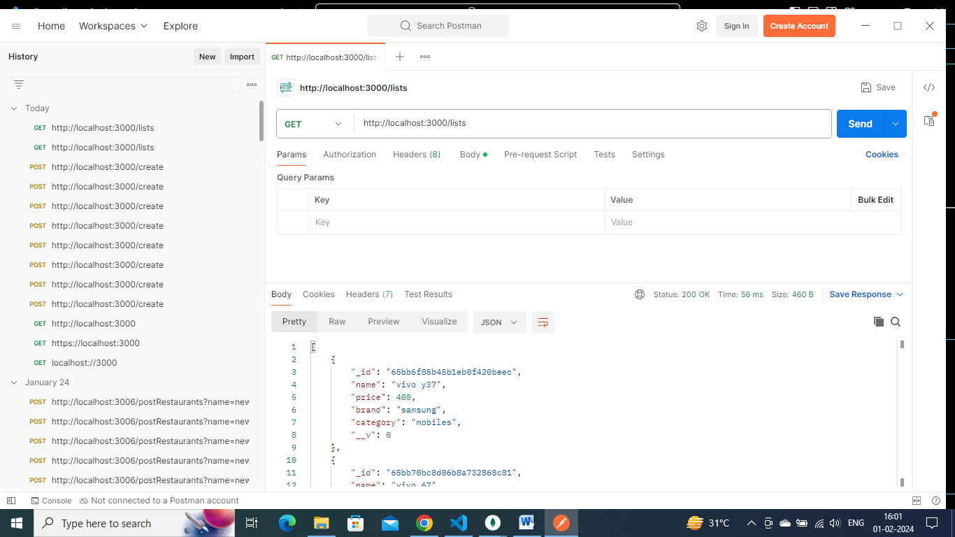

**Delete method- give id/ name to delete a row/collection.**

**To delete using id will be better, as id will be unique for each row**

app.delete('/delete/:id',(req,res)=>{

    console.log(req.params)

    res.send("done delted")

})

**In place of : id – we can give any id / name .**

**This is known as dynamic routing**

**So whatever we enter after localhost:3000/delete/89858696**

**89858696 – this user entered id will get stored into req.params.**

**Suppose from above data I want to delete vivo67 collection/row**

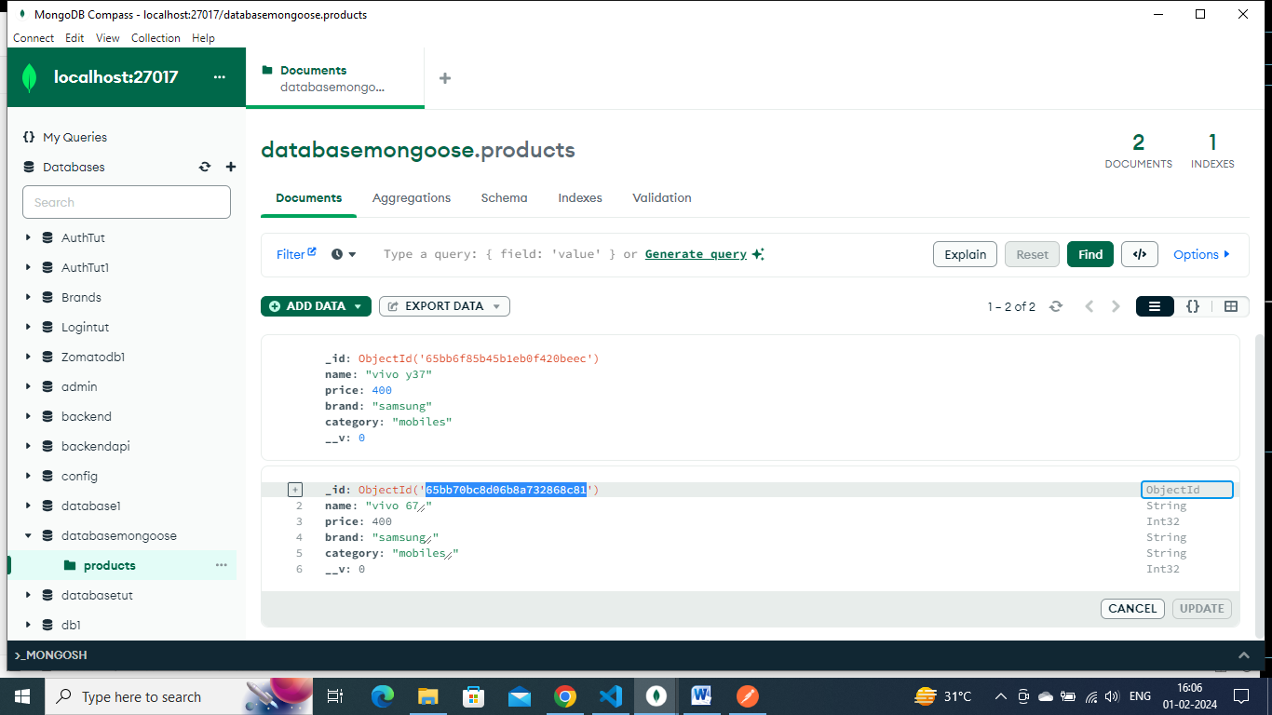

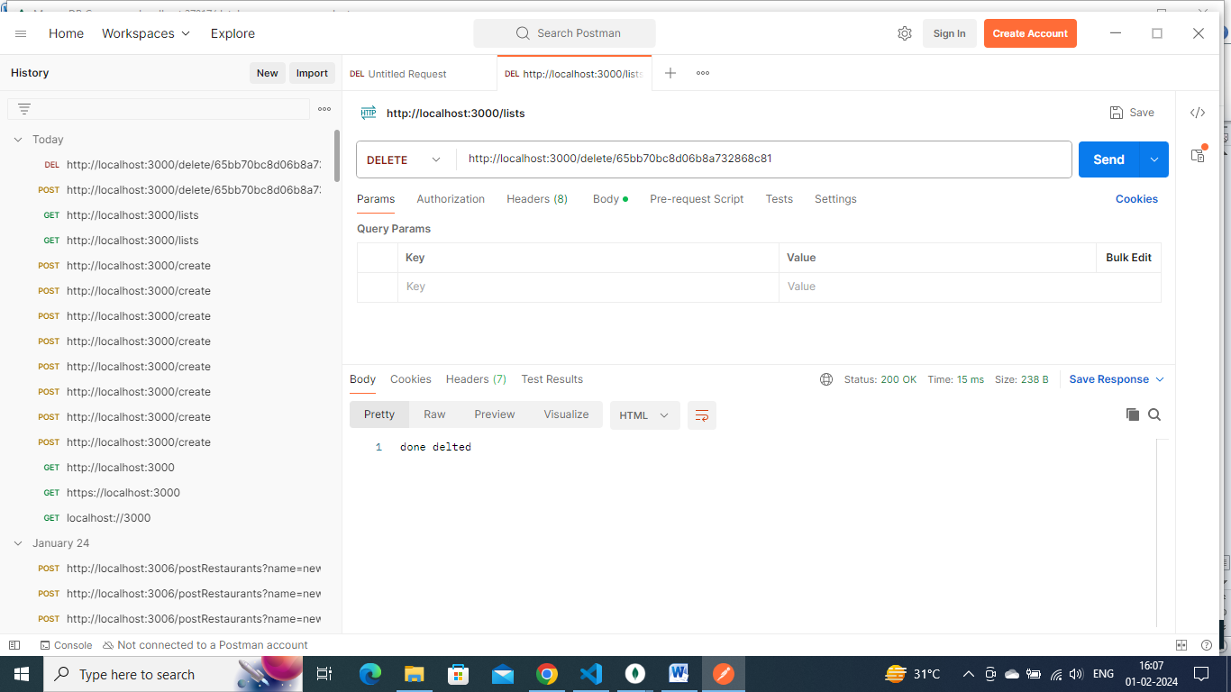

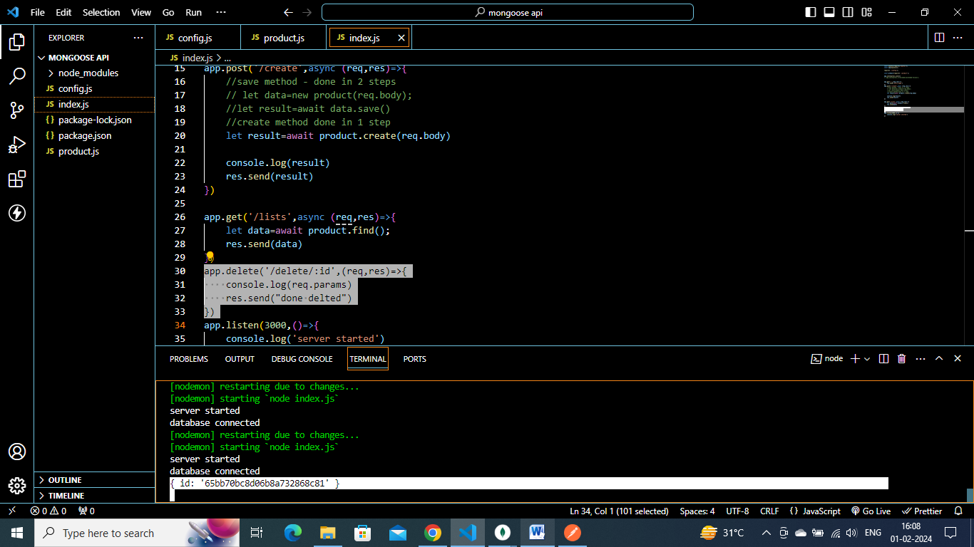

**As I done console..log(req.params) – I got this entered id in console terminal**

**We can use deleteOne() method of mongodb**

    let data=await product.find({id:'65bb70bc8d06b8a732868c81'});

**but** {id:'65bb70bc8d06b8a732868c81'}this part we already getting from req.params

so we can do like this

    let data=await product.find(req.params);

**but in mongodb – field/col name is _id**

**but in**

app.delete('/delete/:id',(req,res)=>{

**here we are taking user entered id into variable id**

**so we can do like this**

app.delete('/delete/:_id',(req,res)=>{

app.delete('/delete/:_id', async (req,res)=>{

    console.log(req.params)

    // let data=await product.find({id:'65bb70bc8d06b8a73s2868c81'});

    let data=await product.deleteOne(req.params);

    res.send(data)

})

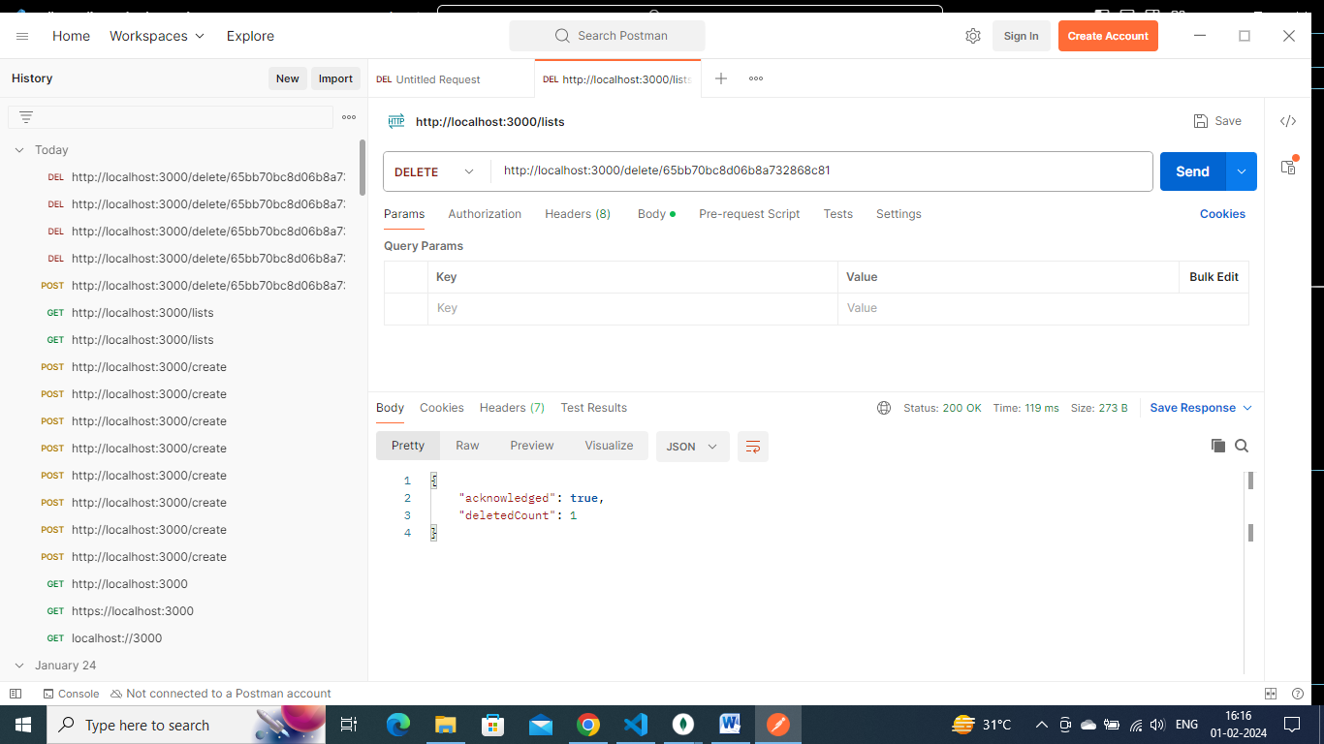

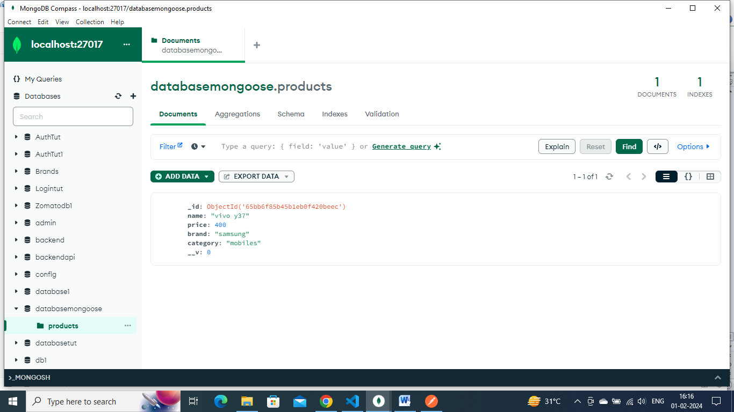

Vivo67 collection/row got deleted

**Put(update):**

We can use updateone method

    let data=await product.updateOne(condition, newsetting values)

app.put('/update/:id',(req,res)=>{

    console.log(req.params);

    let data=await product.updateOne(condition, newsetting values)

})

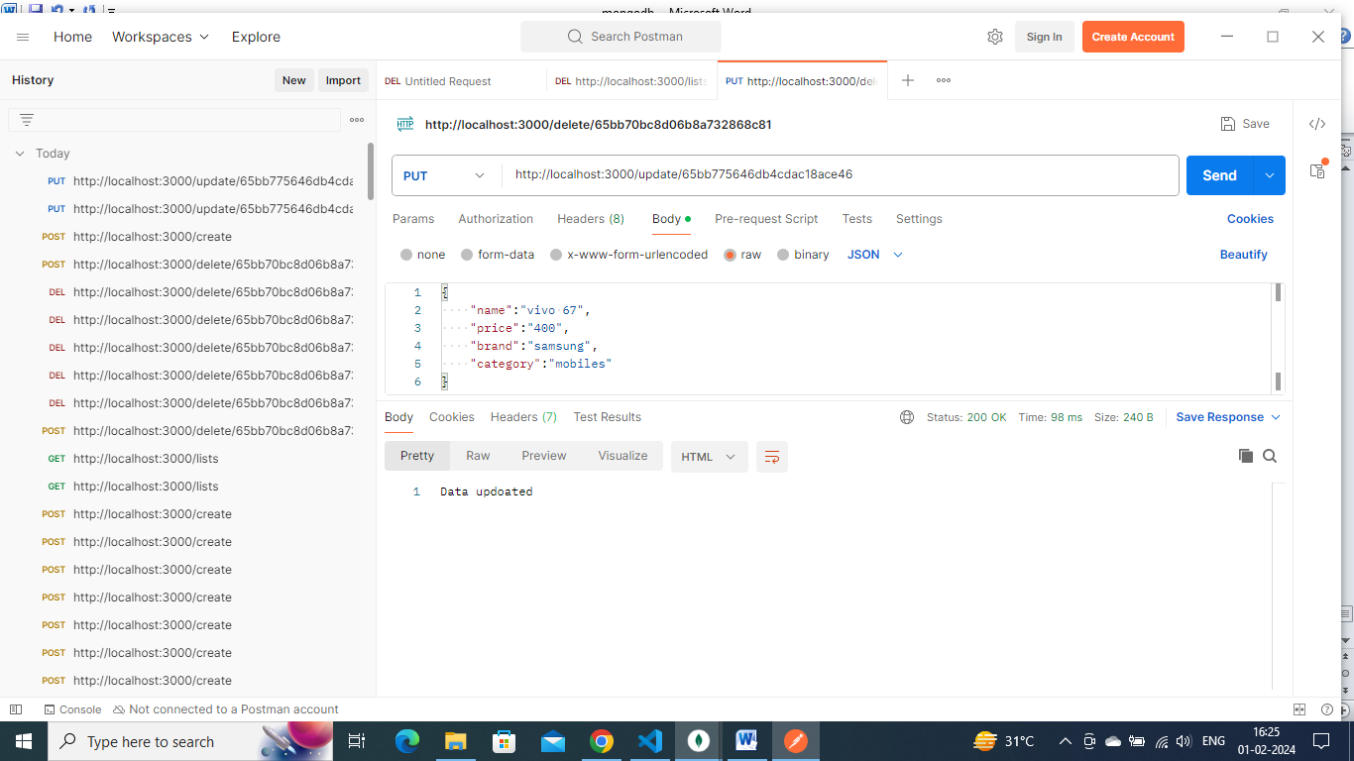

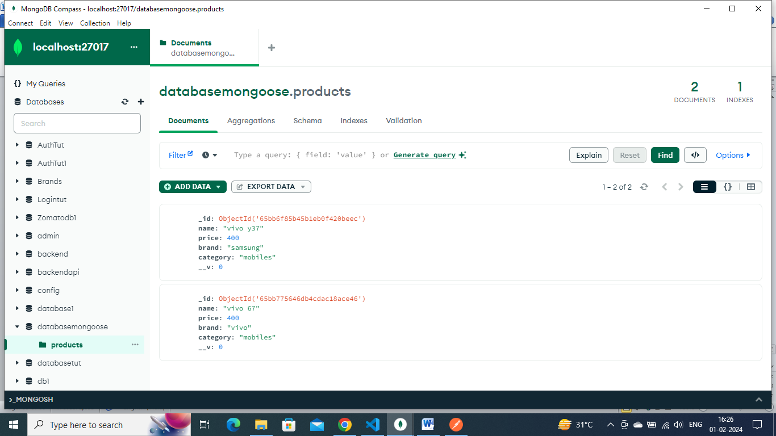

We can do dynamicallylike this

        let data=await product.updateOne(req.params,{$set: req.body})

we can send updated brand/price in body of postman

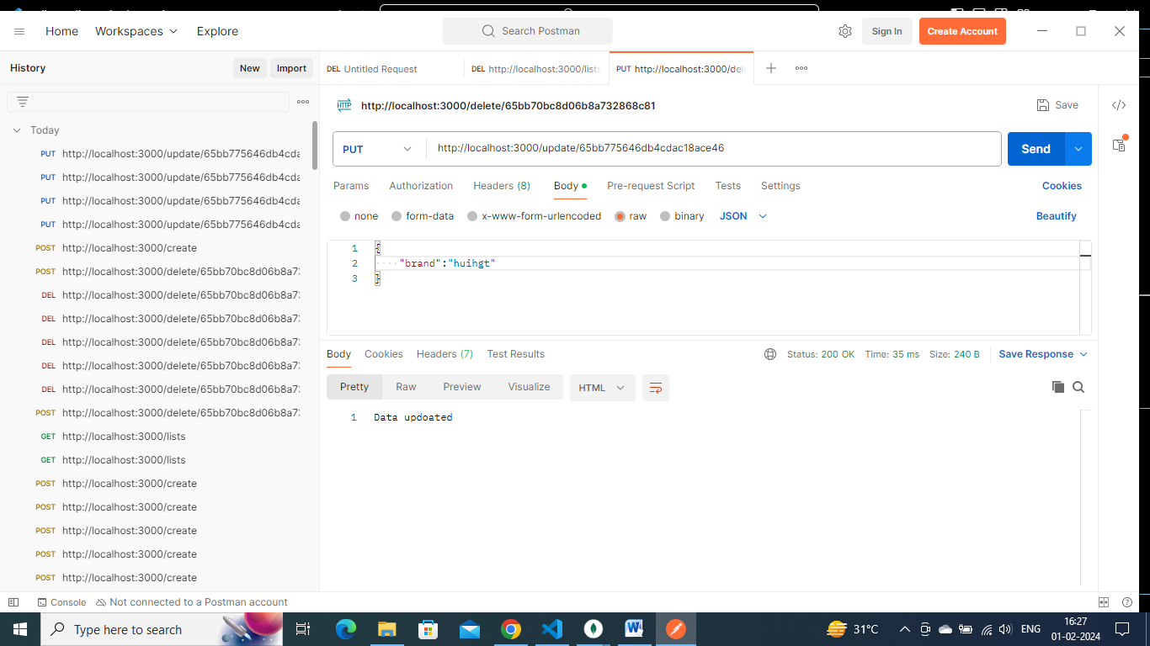

app.put('/update/:_id',async (req,res)=>{

    console.log(req.params);

    // let data=await product.updateOne(condition, newsetting values)

        // let data=await product.updateOne({name:"vivo 67" } ,{$set: {brand:"vivo"}})

        let data=await product.updateOne(req.params,{$set: req.body})

        res.send(data)

})

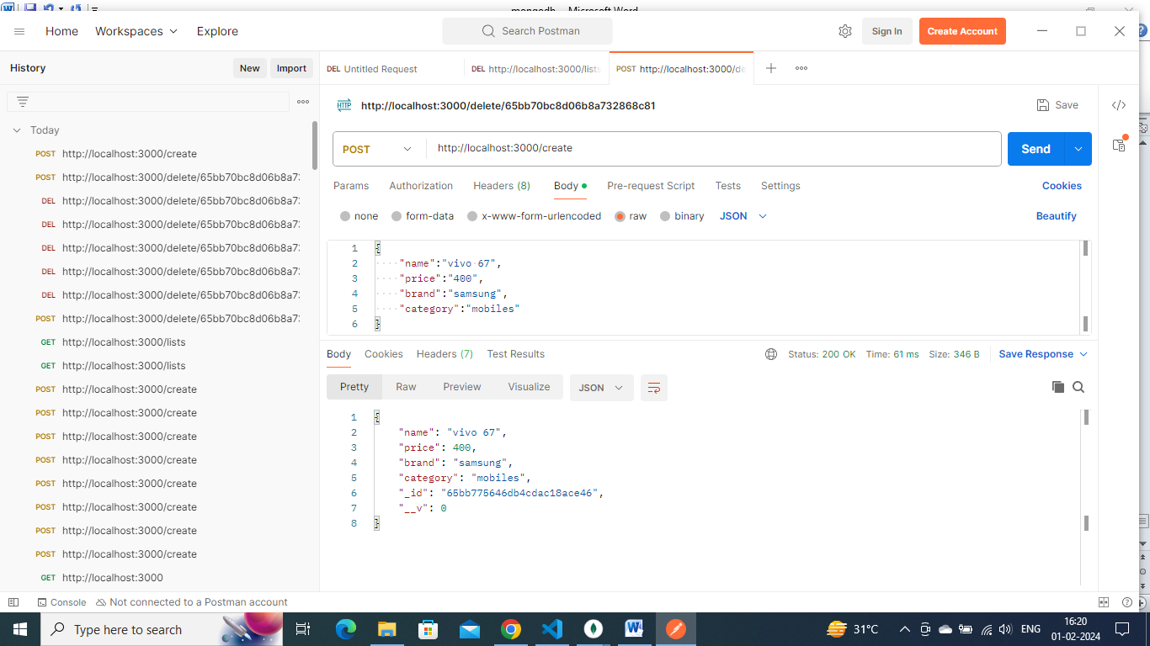

Suppose I want to change the brand from Samsung to vivo where the mobile name is vivo 67

Then I can write query/command as

        // let data=await product.updateOne({name:"vivo 67" } ,{$set: {brand:"vivo"}})

app.put('/update/:id',async (req,res)=>{

    console.log(req.params);

    // let data=await product.updateOne(condition, newsetting values)

        let data=await product.updateOne({name:"vivo 67" } ,{$set: {brand:"vivo"}})

        res.send('Data updoated')

})



app.put('/update/:_id',async (req,res)=>{

    console.log(req.params);

    // let data=await product.updateOne(condition, newsetting values)

        // let data=await product.updateOne({name:"vivo 67" } ,{$set: {brand:"vivo"}})

        let data=await product.updateOne(req.params,{$set: req.body})

        res.send(data)

})

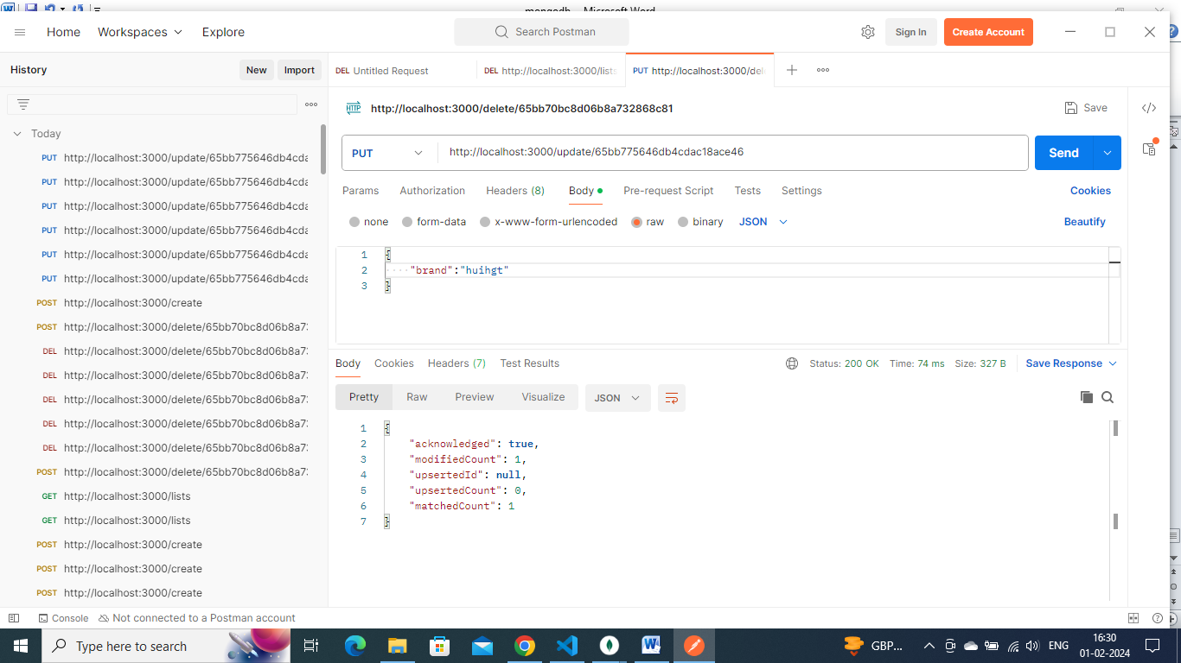

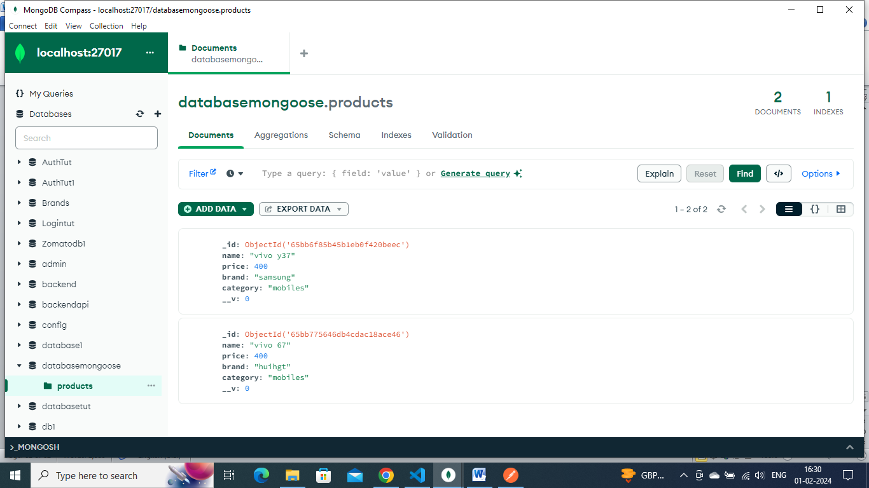

Brand updated

**mvc architecture: refer day 62 diy**

can divide the db connection into another file

we can have many schemas and models in a project.

We can have many collections

Lets take ecommerice website= can have cart collection, products collection, user collection

So we can keep a models folder . inside it can have all these.